Name: ______________ Table #: ____Period:____ Date: ___
1.0A The Handshake Activity_Classwork
Objective: Students will be able to construct diagram as a mathematical model (MP4).
HW: 1.0A Solving Equations

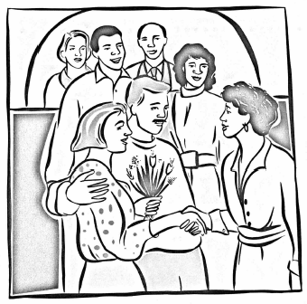
The Wongs had one of their home-cooked banquets for friends. They invited three couples, who all arrived at the same time. Mrs. Wong went to the door to greet them while Mr. Wong stayed in the kitchen to put some finishing touches on the meal. Some handshaking went on at the door between various guests and Mrs. Wong and among the guests themselves. But no one shook hands with her or his own partner, no one shook hands with the same person more than once, and no one was silly enough to shake his or her own hand.
Questions:
- What is the maximum number of hands that Mrs. Wong can shake?
- What is the maximum number of different handshakes?

