Name: _______________________ Table #: _______ Period: _____ Date: _____
1.0B Intro to Using Integers_Classwork
Objective: Students will be able to use real-life application to explore integers
CC.SS.7.NS.1 and CC.SS.7.NS.3

- What is a thermometer? How do you use a thermometer?

- How can you describe to your friend about the temperature outside using descriptive words?

- How can you describe to your friend about the temperature outside using numerical values?

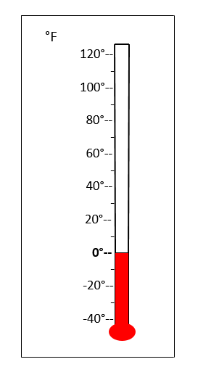  Use the themometer to help you answer the questions | - Use colder/hotter and less than/greater than to describe each problem.  - $-14 F° is _________ than -6°, and-14 is _________ _________ -6$  - $-6 F° is _________ than -14, and-6 is _________ _________ -14$  - Put these temperature in order from smallest to largest (or coldest to warmest)  38°, 70°, -10°, 15°, -6°, 45°, 0°  _____, ______, _____, _____, _____, _____, _____  - Which of the temperatures are positive?  - Which of the temperature are negative?  - Is 0 a positive or negative number?
What is Absolute Value?
- Absolute Value is the distance from zero on a number line.
- Distance is always positive.
- Absolute value symbol is ||.

For each problem you need draw a diagram to explain each answer.
Example 1: |-3| | Example 2: |4|
Practice 1: |6| | Practice 2: |$-9|$

Homework: page 7
https://kttmc.weebly.com/uploads/2/1/2/7/21275598/real_life_exampl_common_core.pdf

Resources:
http://map.mathshell.org/download.php?fileid=1625
https://www.oercommons.org/authoring/13198-integers-introduction-to-the-concept-with-activiti/1/view

