Name: ___________________________________ Table # ____ Per _______ Date _____________
1.0D HW (Solving equations with variables on both sides. CCSS 8.EE.7b)

SOLVE THE FOLLOWING EQUATIONS.
***Make sure to show work and check answers. If you get an answer correct, circle it and put a check mark next to the answer. If you get it wrong and can’t figure out what went wrong, write question marks next to your work.

- 7k + 11 = 3k – 1 | - 2m – 4 = m
- 2(n – 3) = 4n + 1 | - 2x = 7x - 15
- 2x + 4 = - (-7x + 6)  (HINT: when you see a negative sign without a value, put a 1) | - 2(4z – 1) = 3(2z + 2)
- 3(2w – 12) = 24w | - Find x. Then find the perimeter for the square.  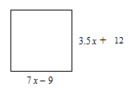
BACK
Challenge question:
The perimeter of the rectangle is EQUAL to the perimeter of the square. What are the side lengths and widths of each figure?
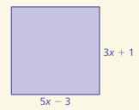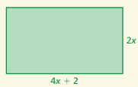

SQUARE: length = _____ width = _____ RECTANGLE: length = _____ width = _____

SOLUTIONS: 1) -3 2) 4 3) -3.5 4) 3 5) 2 6) 4 7) -2 8) x= 6 and perimeter=132

