Name: _________________________ Table #: ________ Period: ______ Date: _______
1.1B Integers and Absolute Values_Classwork
Objective: Students will be able to interpret word problems into numerical values and apply to real-life application
CC.SS.7.NS.1 and CC.SS.7NS.3
Watch before taking notes: http://www.virtualnerd.com/common-core/grade-6/represent-real-world-examples
Bank Activity
Read the paragraph and answer the essential question: How much money does he have in his bank at the end?

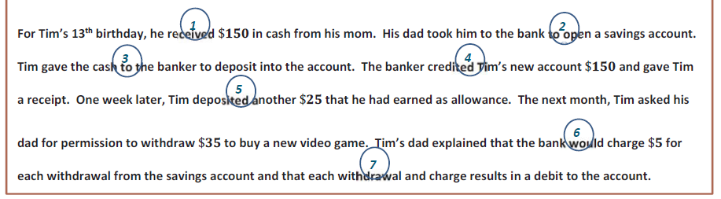

CLAIM (How much money does he have in his bank at the end?)

EVIDENCE (What work did you do to solve this problem? Write a numerical value for each sentence)

REASONING (Summarize in two to three sentences how you know you are correct.)

BACK
Practice Problems
Problem 1: Circle the word that determines whether it is negative or positive. Translate into an expression with integers:

- The temperature is 12 degrees Fahrenheit below zero. ______________________

- The football team had a gain of 3 yards. ______________________

- The elevation of the Dead Sea is 1,302 feet below sea level. ______________________

- A checking account is overdrawn by $40. ______________________

- The temperature is nine degrees below zero. ______________________

- The football team had gain of four yards. ______________________

- The scuba diver was eighteen feet below the surface of the water. ______________________

- The elevation of the mountain is one thousand nine hundred ninety-four feet above sea level. _________

- Earnings of 15 dollars. ______________________

- A loss of 20 yards. ______________________

Problem 2: The highest elevation in North America is Mt. McKinley, which is 20,320 feet above sea level. The lowest elevation is Death Valley, which is 282 feet below sea level. What is the distance from the top of Mt. McKinley to the bottom of Death Valley? Draw a number line to help you.

0

Problem 3: Jenny has $2. She earns $5, spends $10, earns $4, then spends $3. How much money does she have or owe?

