Name: ____________________Table #: __________ Period: ______Date

1.2A Adding Integers HW

4 Activity: Adding Integers with Different Signs

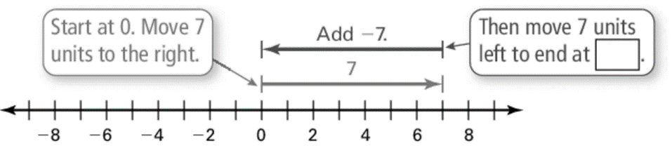Work with a partner. Write the addition expression shown. Then find the sum. How are the integers in the expression related to 0 on a number line?

Inductive Reasoning

Work with a partner. Use integer counters or a number line to complete the table.

|  |  |  |  |
| --- | --- | --- | --- |
| Exercise | Type of Sum | Sum | Sum: Positive,  Negative, or Zero |
| 5. |  |  |  |
| 6. |  |  |  |
| 7. |  |  |  |
| 8. |  |  |  |
| 9. |  |  |  |
| 10. |  |  |  |
| 11. |  |  |  |
| 12. |  |  |  |
| 13. |  |  |  |
| 14. |  |  |  |
| 15. |  |  |  |