Name: _____________________________
Table #: ______ Period: _____ Date: _____
1.3C_Practice Quiz 1.1-1.3 HW
Login BIM and submit answers online. Show work and write answer on this worksheet.

- Find the absolute value of 3.

- Find the absolute value of -7

- Compare -6 and |-5|. Which one is greater?

- Find 8 + 12

- Find 4 + (-2)

- Find 4 – (-11)

- Evaluate the expression -4 – (-8) -4

- EXTRA CREDIT

- The table shows the change in temperature each hour for four hours. Find the total change C in temperature.
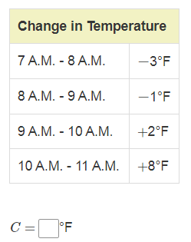

- The table shows the maximum and minimum depths of two submarines. Find the range of depths for each submarine. Then determine which submarine has the greater range of depth
