Name __________________ Table # ____ Period ___ Date ____
1.5A Dividing Integers_Classwork
Objective: CCSS 7.NS.2b and 3
Dividing Integers with the Same Sign: the quotient of two integers with the same sign is positive.
$\frac{8}{4}=$8 ÷ 4 = ______ | $\frac{-16}{-2}=$ _______= ____ | $\frac{20}{4}= _______=_____$

Dividing Integers with Different Signs: The quotient of two integers with different signs is negative
$\frac{-21}{7}=$ -21 ÷ 7 = ______ | $\frac{14}{-2}=$ _______= ____ | $\frac{-15}{3}=$ _______= ____

Problems | Fraction | Type of Quotient | Positive, Negative, or Zero | Quotient (Answer)
- -15 ÷ 3
- 12 ÷ 4
- 12 ÷ (-3)
- -12 ÷ -4
- 0 ÷ -15
- 4 ÷ 0

Use order of operations: P/E/MD/AS
________________________________________________________________________

Evaluate the expression when a = -18 and b = -6
- $10-a÷b$ | - $\frac{(a+6)}{3}$ | - $\frac{b^{2}}{a}+4$

Problem 1:
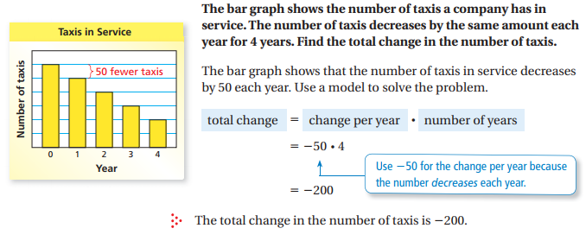

Problem 2: An alligator population in a nature preserve in the Everglades decreases by 60 alligators over 5 years. What is the mean yearly change in the alligator population?
“Mean” is another word for _________________________________________________

Problem 3: You read 105 pages of a novel over 7 days. What is the mean number of pages you read each day?

