Name: _________________________________________ Table# ___ Period _____ Date _________

10.1A Outcomes and Events_Classwork

Objective: Students will be able to construct viable arguments and critique the reasoning of others MP3.
CC.SS.7.SP.5 identify and count the outcomes of experiments.
HW: textbook_pg 404_#3-11 ALL (copy the problem before answering)
WARM-UP
- Evaluate: $4^{2}-5(3)$ | - Evaluate: $\frac{3}{2}+\frac{1}{2}$ | - What makes a game fair?

Rock Paper Scissors Experiment
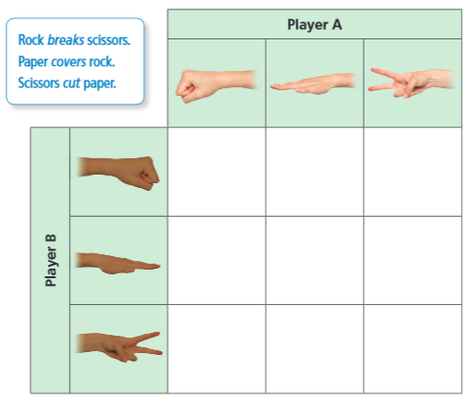
- How many possible results (outcomes) are there? Explain your reasoning.

- Play Rock Paper Scissors 20 times. Tally your results in the table.

- Of the possible results, in how many ways can:
Player A win? Player B win? The players tie?

- Does one of the players have a better chance of winning than the other player? Explaining your reasoning.

- Is this a fair game?

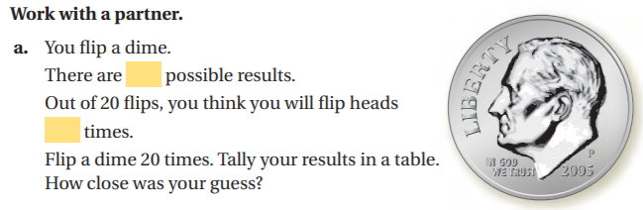 | HEADS TAIL
Experiment:

Possible Outcomes:

Event:

Favorable Outcomes:

Spinner Problem
1.
2.
3.
4.

Marble Problem
1.
2.
3.
4.

Letters Problem
You randomly choose a letter from a hat that contains the letters A through K.
- What are the possible outcomes?

- What are the favorable outcomes of choosing a vowel?

