Name: _________________________________________ Table# ___ Period _____ Date _________
10.2A NOTES – Product of Powers Property
Objective: CCSS.8.EE.1 (MP8 Look for and Express Regularity in Repeated Reasoning)
Complete an exit slip at the end

Prime Number: a whole number greater than 1 whose only factors are 1 and itself. Ex: 2, 3, 5, 7, 11, 13…

WARM-UP

EXAMPLE: Write the prime factorization Write the prime factorization of 675
of 648 using exponents using exponents
648
2 ^ 324
2 ^ 162
2 ^ 81
9 ^ 9
3 ^ 3 3 ^ 3

PRIME FACTORIZATION: 2³ ∙ 3⁴ PRIME FACTORIZATION: ________________

- Write the expression as a single power. Then write a general rule for finding a product of power.

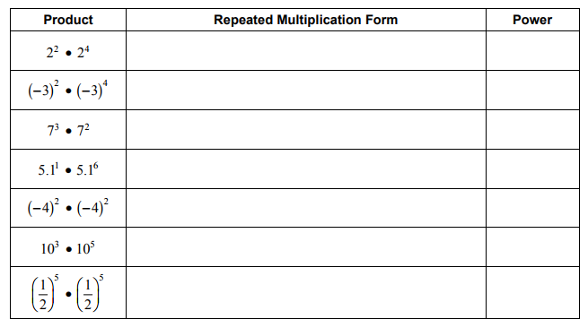
RULE
a^{m} ∙ a^{n} =
Describe the pattern in the table.

BACK
- Write the expression as a single power. Then write a general rule for finding a power of a power.
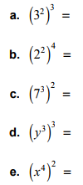

RULE
(a^{m})^{n} =
Describe the pattern

_________________________________________________________________________

How can you rewrite 2 as an exponential form? _________________________

- Write the expression as the product of two powers. Then write a general rule for finding a power of a product.
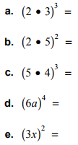

RULE
($a^{p}$∙$b^{n}$)^{m} =
Describe the pattern.

Name: _________________________________________ Table# ___ Period _____ Date _________
10.2A Product of Power Property EXIT SLIP
Two students were given the following problem: Simplify m⁴ ∙ m⁵
Brenda thought the answer was m⁹. Matthew thought the answer was m²⁰. Which student is correct? How do you know?

CLAIM (Which student is correct?): _________________ is correct.

EVIDENCE (show your work to support your claim; label as needed): | REASONING (Summarize in two to three sentences how you know you are correct.)

Name: _________________________________________ Table# ___ Period _____ Date _________
10.2A Product of Power Property EXIT SLIP
Two students were given the following problem: Simplify m⁴ ∙ m⁵
Brenda thought the answer was m⁹. Matthew thought the answer was m²⁰. Which student is correct? How do you know?

CLAIM (Which student is correct?): _________________ is correct.

EVIDENCE (show your work to support your claim; label as needed): | REASONING (Summarize in two to three sentences how you know you are correct.)

