Name: _________________________________________ Table# ___ Period _____ Date _________
10.2A Product of Powers Property_Classwork
Objective: CCSS.8.EE.1 (MP8 Look for and Express Regularity in Repeated Reasoning)
HW: 10.2A HW

WARM-UP

EXAMPLE: Write the prime factorization Write the prime factorization of 675
of 648 using exponents using exponents
648
2 ^ 324
2 ^ 162
2 ^ 81
9 ^ 9
3 ^ 3 3 ^ 3

PRIME FACTORIZATION: 2³ ∙ 3⁴

- Write the expression as a single power. Then write a general rule for finding a product of power.

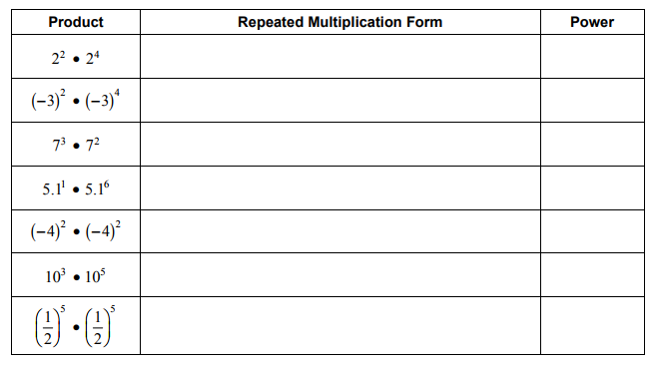
- a^{m} ∙ a^{n} =
- Describe the pattern in the table.

BACK

- Write the expression as a single power. Then write a general rule for finding a power of a power.
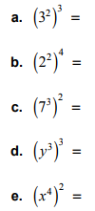

- (a^{m})^{n} =
- Describe the pattern.

- Write the expression as the product of two powers. Then write a general rule for finding a power of a product.
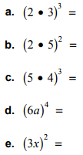

- (a ∙ b)^{m} =
- Describe the pattern.

