Name: _________________________________________ Table# ___ Period _____ Date _________
10.2B Product of Powers Property_Classwork
Objective: CCSS: 8.EE.1 (Apply the properties of integer exponents to generate equivalent numerical expressions)
HW: (10.2B) P. 420 #3 – 13 odd, 17 – 23 all. Solutions on p. A39. Copy down the problem, show work, check odd answers

Fill in the blank for the “Study Tip” on p. 418.
Then do On Your Own #1 – 9. Remember to show your work.
STUDY TIP: When a number is written without an exponent, its exponent is ______

READ EXAMPLE 1 (p. 418) – For OYO #1 – 3: Simplify the expression.
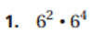 | 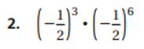

READ EXAMPLE 2 (p. 418) – For OYO #4 – 6: Simplify the expression.
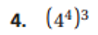 | 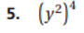

READ EXAMPLE 3 (p. 419) – For OYO #7 – 9: Simplify the expression.
