Name: ________________________________ Table #: ________ Period: __________ Date: ________
10.3A NOTES – Quotient of Powers Property
CCSS: 8.EE.1 (Divide powers with the same base)
HW: (10.3A) p. 426 #1 – 15 al. Do in Big Ideas Math (remember to copy down the problem, show your work, and check answers on p. A39)

Evaluate $\frac{2∙2∙2∙3∙3∙4}{2∙2∙3∙3∙3}$

CW: 10.3 Activity in R&P p. 211
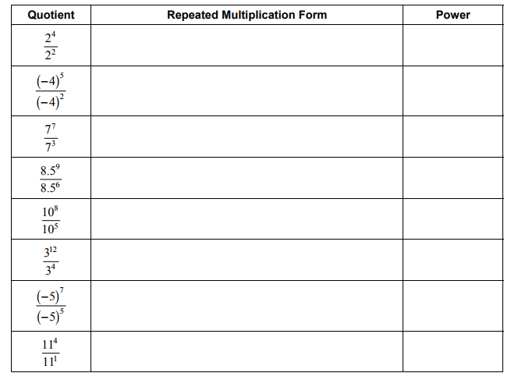
b. Describe the pattern in the table. Then write a rule for dividing two powers that have the same base.

KEEP THE BASE THE SAME AND ___________________ THE EXPONENTS
CREATE YOUR OWN EXAMPLE:

EXAMPLE
$\frac{a^{m}}{a^{n}}= a^{________}$

$\frac{3^{10}}{3^{6}}=$
BACK
ADDITIONAL EXAMPLES BEFORE STARTING CLASSWORK:
Simplify the expression. Write your answer as a power.

Warm Up:

Is 3² + 3³ equal to 3⁵? Explain.

