Name: ________________________________ Table #: ________ Period: __________ Date: ________
Lesson 10.3A Quotient of Powers Property_Classwork
Objective: divide powers with the same base; simiplify expressions involving the quotient of powers. CC.SS.EE.1

Evaluate $\frac{2∙2∙2∙3∙3∙4}{2∙2∙3∙3∙3}$

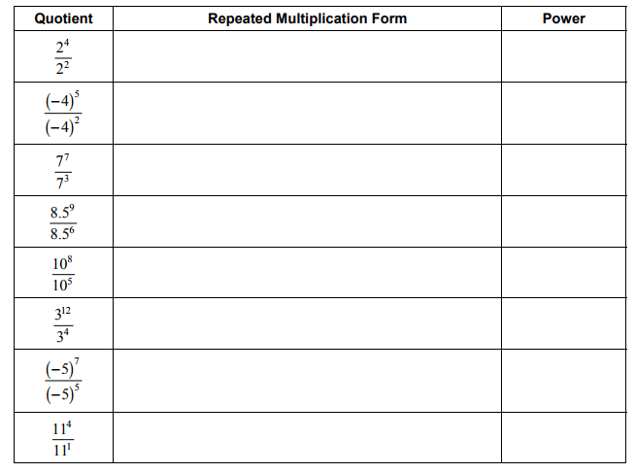
b. Describe the pattern in the table. Then write a rule for dividing two powers that have the same base.

KEEP THE BASE THE SAME AND ___________________ THE EXPONENTS

$\frac{a^{m}}{a^{n}}= a^{________}$ $\frac{3^{10}}{3^{6}}=$

ADDITIONAL EXAMPLES BEFORE STARTING CLASSWORK:
Simplify the expression. Write your answer as a power.

CW: (10.3A) p. 426 #3 – 14 all
Remember to copy down the problem, show your work, and check answers on p. A39

