Name: ___________________________ Table# ____ Period _____ Date ___________
10.3A Theoretical Vs Experimental Probability_Classwork

Objective: Attend to Precision (MP6). Use experimental probabilities to make predictions; use theoretical probabilities to find quantities; compare experimental and theoretical. CCSS.7.SP.5, CCSS.7.SP.6, and CCSS.7.SP.7

What do you know about probability?

Contrast experimental and theoretical probability
Experimental Probability | Theoretical Probability:

Example 1
Experimental Probability | Theoretical Probability:

Experimental vs Theoretical

Theoretical Probability:

Experimental probability:

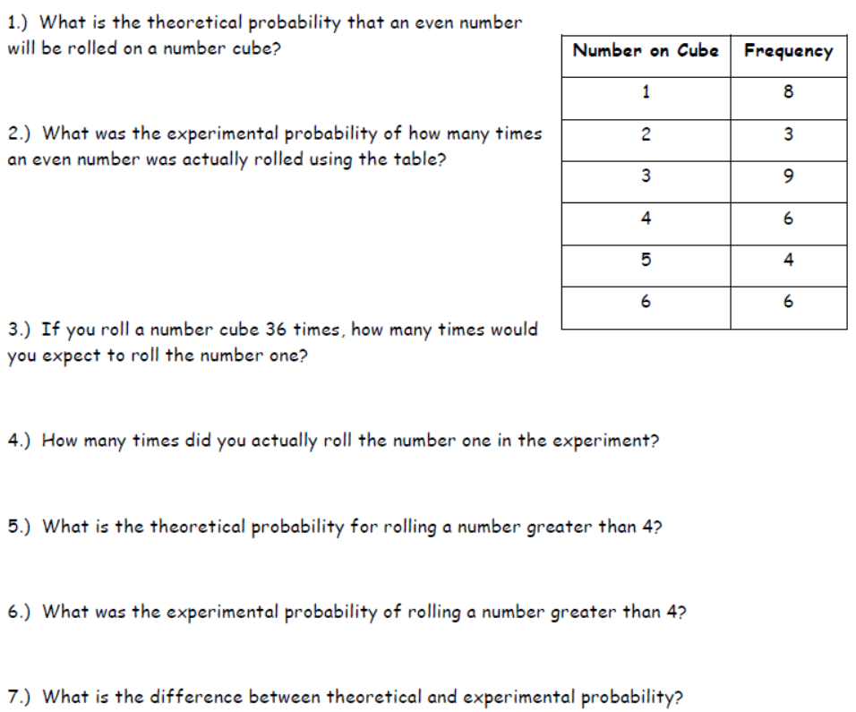

HW: worksheet- 10.3A HW- 10.3 Practice pg 220

Solutions: 1) 1/2 2) 4/9 3) 6 4) 8 5) 1/3 6) 5/18
7) theo= what should happened; exp= what actually happens

