Name Date
Practice
For use after Lesson 10.3
10.3
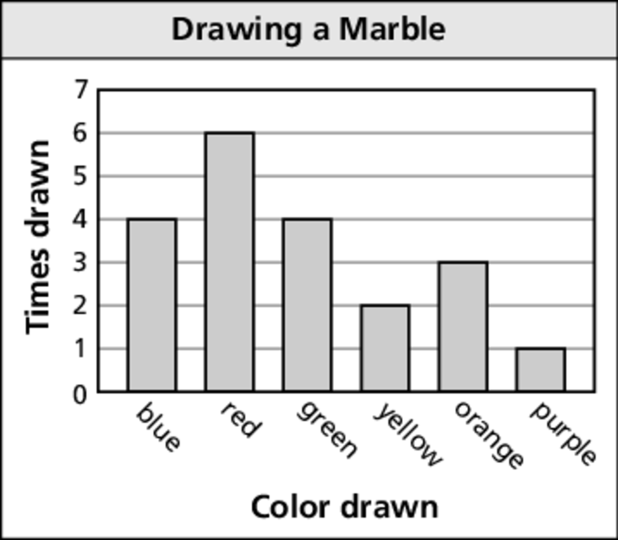
Use the bar graph to find the experimental probability
of the event.
1. Drawing red 2. Drawing orange

3. Drawing not yellow 4. Drawing a color with more than 4 letters in its name

5. There are 25 students’ names in a hat. You choose 5 names. Three are boys’ names and two are girls’ names. How many of the 25 names would you expect to be boys’ names?

Use a number cube to determine the theoretical probability of the event.
6. Rolling a 2 7. Rolling a 5

8. Rolling an even number 9. Rolling a number greater than 1

