Name: ________________________________ Table #: ________ Period: __________ Date: ________
10.3B NOTES – Quotient of Powers Property
Objective: divide powers with the same base; simiplify expressions involving the quotient of powers. CC.SS.EE.1
HW: (10.3B) p. 426 #16 – 21, 23 – 28.

Warm Up. SIMPLIFY EACH EXPRESSION. WRITE YOUR ANSWER AS A POWER.
$$1. \frac{4^{5}}{4^{2}}$$ | 2. $\frac{{\left(-2\right)}^{10}}{{\left(-2\right)}^{3}}$ | 3. $\frac{P^{7}}{P^{6}}$

STEPS:
- Simplify the numerator (use the Power Rule)
- Simplify the denominator (use the Power Rule)
- Simplify the top and bottom (use the Quotient Rule)
- Make sure to simplify the coefficient if needed.

EXAMPLE 2 (P. 424) AND ONE ADDITIONAL EXAMPLE.
SIMPLIFY THE EXPRESSION. WRITE YOUR ANSWER AS A POWER
1) $\frac{3^{4}∙ 3^{2}}{3^{3}}$ | 2) $\frac{7x^{5}}{x^{3}}$

SIMPLIFY THE EXPRESSION. WRITE YOUR ANSWER AS A POWER
5a. $\frac{2^{15}}{2^{3} ∙ 2^{5}}$ | 5b. $\frac{π^{10}}{π^{5} ∙ π^{4}}$
5c. $\frac{k ∙ 3^{9}}{3^{5}}$ | 5d. $\frac{x^{4} ∙ y^{10} ∙ 2^{11}}{{y^{8} ∙2}^{7}}$
BACK
READ EXAMPLE 3 (p. 425)
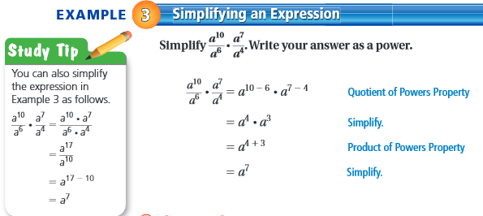

Simplify the expression. Write your answer as a power.
- $\frac{35x^{11}}{15x^{4}}$

- $\frac{12x^{5}}{2x}$

ON YOUR OWN: Simplify the expression. Write your answer as a power.
6.  $$\frac{d^{5}}{d}∙\frac{d^{6}}{d^{8}}$$ | 7.  $$\frac{5^{9}}{5^{4}}∙\frac{5^{5}}{5^{2}}$$ | 8.  $$\frac{9x^{3}}{6}∙\frac{2y^{8}}{2y^{6}}$$

EXAMPLE 3 (p. 425).  SIMPLIFY EACH EXPRESSION. WRITE YOUR ANSWER AS A POWER WITH POSITIVE EXPONENTS  - $\frac{a^{10}}{a^{6}} ∙ \frac{a^{7}}{a^{4}}$ | ADDITIONAL EXAMPLE  - $-\frac{10x^{9}}{18x^{5}} ∙ \frac{y^{4}}{y^{2}}$

PRACTICE PROBLEMS
SIMPLIFY EACH EXPRESSION. WRITE YOUR ANSWER AS A POWER WITH POSITIVE EXPONENTS
1.  $$\frac{7^{5}∙7^{6}}{7}$$ | 2.  $$\frac{π^{15}}{π^{3}∙π^{9}}$$ | 3.  $$\frac{5^{12}}{5^{6}∙5^{3}}$$

