Name: ________________________________ Table #: ________ Period: __________ Date: ________
Lesson 10.3C Quotient of Powers Property_Classwork
Objective: divide powers with the same base; simiplify expressions involving the quotient of powers. CC.SS.EE.1
HW: worksheet 10.3C HW
SIMPLIFY EACH EXPRESSION. WRITE YOUR ANSWER AS A POWER.
- $\frac{3^{5}}{3^{0}}$ 2. $\frac{{\left(-4\right)}^{7}}{{\left(-4\right)}^{3}}$ 3. $\frac{x^{8}}{x^{7}}$

READ EXAMPLE 3 (p. 425)
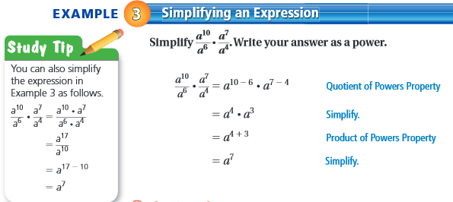

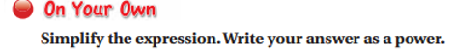
6.  $$\frac{d^{5}}{d}∙\frac{d^{6}}{d^{8}}$$ | 7.  $$\frac{5^{9}}{5^{4}}∙\frac{5^{5}}{5^{2}}$$ | 8.  $$\frac{9x^{3}}{6}∙\frac{2y^{8}}{2y^{6}}$$

WARM-UP
SIMPLIFY EACH EXPRESSION. WRITE YOUR ANSWER AS A POWER WITH POSITIVE EXPONENTS
1.  $$\frac{7^{5}∙7^{6}}{7}$$ | 2.  $$\frac{m^{12}∙m^{2}}{m∙m^{6}}$$ | 3.  $$\frac{5^{12}}{5^{6}∙5^{3}}$$
4.  $$\frac{π^{15}}{π^{3}∙π^{9}}$$ | 5.  8dd⁵ | 6.  $$\frac{{12p}^{5}}{{4p}^{7}}$$

EXAMPLE 3 (p. 425).
SIMPLIFY EACH EXPRESSION. WRITE YOUR ANSWER AS A POWER WITH POSITIVE EXPONENTS
$$\frac{a^{10}}{a^{6}} ∙ \frac{a^{7}}{a^{4}}$$ | $$\frac{a^{10}}{a^{6}} ∙ \frac{a^{7}}{a^{4}}$$
Additional Example
$$-\frac{10x^{9}}{18x^{5}} ∙ \frac{y^{4}}{y^{2}}$$

