Name Date

**10.4B Compound Events_Homework**

1. Use a tree diagram to find the total number of possible outcomes.

|  |  |
| --- | --- |
| Bed Sheets | |
| Size | Twin, Twin XL, Full, Queen, King |
| Style | Solid, Patterned |

Use the Fundamental Counting Principle to find the total number of possible outcomes.

2. 3.

|  |  |
| --- | --- |
| Photos | |
| Size | Wallet, 4 by 6, 5 by 7,  8 by 10, 11 by 14, 16 by 20 |
| Finish | Matte, Glossy |
| Edits | Red eye, Black and white, Crop |

|  |  |
| --- | --- |
| Laptops | |
| Hard Drive | 250 GB, 320 GB, 500 GB |
| Style | HD, LCD |
| Color | Black, White, Red, Blue, Pink, Green, Purple |

You spin the spinner and flip a coin. Find the probability of the events.

4. Spinning a 2 and flipping tails

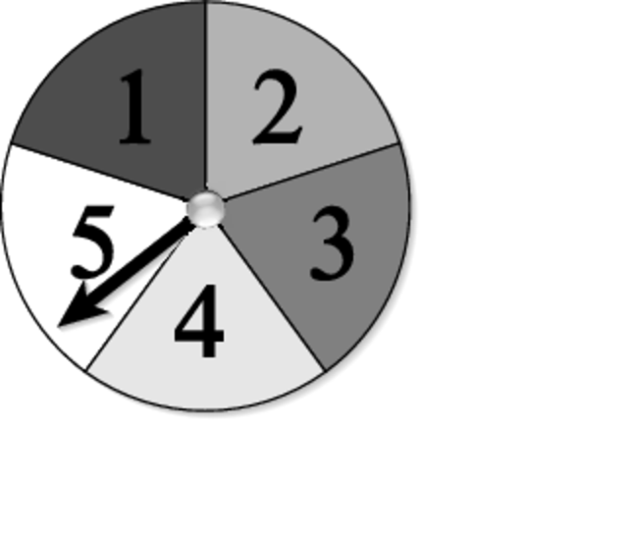

5. Spinning a 7 and flipping heads

6. *Not* spinning a 4 and flipping tails

**Login Big Ideas Math and complete 10.4 Exercise #1-20 ALL**