Name: ___________________________________ Table# _______ Period _____ Date _____________

10.4C “Which Lock is Better?”_Classwork

Question:
You are buying a combination lock. You have three choices:
- Lock 1 has 3 wheels. Each wheel is numbered from 0 to 9.
- Lock 2 has numbered from 0 to 39. Each combination uses 3 numbers.
- Lock 3 has 4 wheels. Wheel 1: 0 to 9, Wheel 2: A to J, Wheel 3: K to T, and Wheel 4: 0 to 9
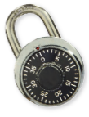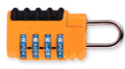
Lock 1 Lock 2 Lock 3

CLAIM (Which lock would you get?)

EVIDENCE (What work did you do to solve this problem?)
Lock 1 | Lock 2 | Lock 3

REASONING (Summarize in two to three sentences how you know you are correct.)

