Name: _________________________________________ Table# ___ Period _____ Date _________

10.5 & 10.6 NOTES – Reading and Writing Scientific Notation

Lesson Launch
SCIENTIFIC NOTATION  X 10  FACTOR POWER OF 10  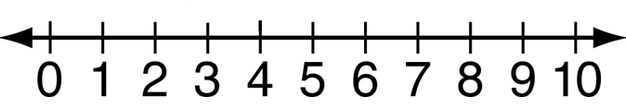  Your factor should be somewhere in this region | Fill in the blanks:  $7 ∙10 = ___________$  $7 ∙100 = __________$  $7 ∙1,000 = _________$  $7 ∙10,000 = ________$ | Fill in the blanks:  $50,000 ∙{10}^{0}= _________$  $5,000 ∙{10}^{1}= ________$  $$500 ∙{10}^{2}= _________$$  $$50 ∙{10}^{3}= __________$$  $$5 ∙{10}^{4}= _____________$$

Watch video: https://www.youtube.com/watch?v=Dme-G4rc6NI
DEFINITION OF SCIENTIFIC NOTATION
The product of a FACTOR and a power of 10. The factor must be GREATER THAN OR EQUAL TO 1 or LESS THAN 10.

EXAMPLES FROM VIDEO. Write the following numbers in SCIENTIFIC NOTATION
1. 3,749,000,000 | 2. 0.00005269
3. 813,000,000,000,000 | 4. 0.0000000214
5. 7.921 x 10⁸ | 6. 8.2 x 10⁻⁵
7. 4.13 x 10³ | 8. 5.2216 x 10⁻⁹
BACK
WRITING NUMBERS IN STANDARD FORM (FROM SCIENTIFIC NOTATION)

If the exponent is NEGATIVE, move the decimal point to the _________________.

If the exponent is POSITIVE, move the decimal point to the _________________.

EXAMPLE 1: Writing Large Numbers in Scientific Notation
A large corporation purchased a video-sharing website for $1,650,000,000. Write this number in scientific notation.

EXAMPL 2: Writing Small Numbers in Scientific Notation
The 2004 Indonesian earthquake slowed the rotation of Earth, making the length of a day 0.00000268 second shorter. Write this number in scientific notation.

WRITE THE NUMBER IN SCIENTIFIC NOTATION
- 50,000 | - 25,000,000 | - 683
- 0.005 | - 0.00000033 | - 0.000506
WRITE THE NUMBER IN STANDARD FORM
- 6 x 10⁷ | - 9.9 x 10⁻⁵ | - 1.285 x 10⁴
SUMMARY
- Is 12 x 10⁴ written in scientific notation? Explain.

HW: (10.5) p. 440 #6 – 11, 15 – 20 AND (10.6) p. 446 #3 – 19 odd (check solutions on p. A40 & 41)
Objective: Write numbers in scientific notation to be able to perform operations in sci. not. (8.EE.4)
Write numbers in standard form from scientific notation.
Explain whether numbers are expressed in scientific notation (pre-requisite to 8.EE.4)

