Name: __________________________ Table #: _______________ Period: _______ Date: ________
10.5A Reading Scientific Notation_Classwork

Objective: Write numbers in standard form from scientific notation.
Explain whether numbers are expressed in scientific notation (pre-requisite to 8.EE.4)
HW: (10.5) p. 440 #6 – 11, 15 – 20 (Solutions on p. A40)

Show: https://www.youtube.com/watch?v=Dme-G4rc6NI
What is the purpose of scientific notation? Where do you see it? Why do we use it?

What does scientific notation look like?

2 EXAMPLES OF SCIENTIFIC NOTATION | 2 NON-EXAMPLES OF SCIENTIFIC NOTATION

DEFINITION OF SCIENTIFIC NOTATION

The product of a _______________________ and a power of _______. The factor must be _____________

______________ or ___________ to 1 and ___________ _____________ 10.
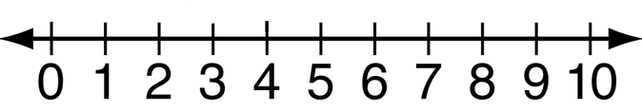

EXAMPLES FROM VIDEO (start at 9:15)
- 7.921 x 10⁸ | - 8.2 x 10⁻⁵
- 4.13 x 10³ | - 5.2216 x 10⁻⁹
- Is 12 x 10⁴ written in scientific notation? Explain.

WRITING NUMBERS IN STANDARD FORM (FROM SCIENTIFIC NOTATION)

If the exponent is NEGATIVE, move the decimal point to the _________________.

If the exponent is POSITIVE, move the decimal point to the _________________.

WRITE THE NUMBER IN STANDARD FORM
- 6 x 10⁷ | - 9.9 x 10⁻⁵ | - 1.285 x 10⁴

