Name: ______________________ Table #: ________ Period: _______ Date: ________
10.6A Writing Scientific Notation_Classwork

Objective: Write numbers in scientific notation to be able to perform operations in sci. not. (8.EE.4)
HW: (10.6) p. 446 #3 – 19 odd (check solutions on p. A41)

Warm up
1. Simplify $\frac{1}{7^{5}} ∙ \frac{1}{7^{-3}}$ | 2. Evaluate 7 ∙ 4⁻¹ + 10

SCIENTIFIC NOTATION

X 10

FACTOR POWER OF 10

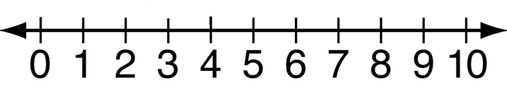 Your factor should be somewhere in this region

https://www.youtube.com/watch?v=Dme-G4rc6NI start at 6:00
EXAMPLES FROM VIDEO. Write the following numbers in SCIENTIFIC NOTATION
- 3,749,000,000 | - 0.00005269
3) 813,000,000,000,000 | 4) 0.0000000214

WRITE THE NUMBER IN SCIENTIFIC NOTATION
- 50,000 | - 25,000,000 | - 683
- 0.005 | - 0.00000033 | - 0.000506

