Name: ________________________________ Table #: _______ Period: _________ Date: _______
10.7B NOTES – Adding and Subtracting In Scientific Notation
Objective: Apply knowledge about power rules to adding and subtracting numbers in scientific notation. CCSS: 8.EE.4
Friday CW: (10.7B) p. 452 #3, 4, 7 – 10 all (do in BIM)

Convert to Scientific Notation:
If you move to the ____________, then it is a NEGATIVE exponent.
If you move to the ____________, then it is a POSITIVE exponent.

Write each problem in scientific notation if necessary.
- 139.45 x 10³  It is important to check your answer. | - .000945 x 10⁻⁴ | - 9.45 x 10⁵

Adding Subtracting Numbers in Scientific Notation:
- When adding or subtracting numbers in scientific notation, the exponents must be the same.
- Add or subtract factors by lining up the decimals.
- Keep the Power the same.
- Write in scientific notation. Make sure the coefficient is greater than 1 and less than 10.
Watch the video and to the two problems: https://www.youtube.com/watch?v=p0zVNTko7z4
Example 1: Adding With Same Exponents  (2.1 x 10³) + (4.4 x 10³) | Example 2: Subtracting With Same Exponents  (8.0 x 10⁵) – (7.6 x 10⁵)
Round factor to the nearest hundredths
You Try 1: Adding With Same Exponents  (9.45 x 10³) + (6.11 x 10³) | You Try 2: Subtracting With Same Exponents  (8.96 x 10⁷) – (3.41 x 10⁷)
BACK
Application
Example 3: How many times greater is the diameter of the Sun than the diameter of the Earth?
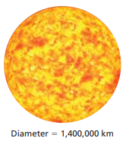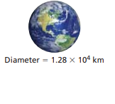
Textbook: #24 pg 452
MONEY. How many times greater is the thickness of a dime than the thickness of a dollar bill?
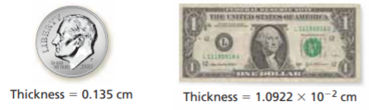

REVIEW Practice Problems
Convert the following numbers into scientific notation:
1) 392 2) 53000

3) 0.00000234 4) 0.00671

Convert the following numbers into standard notation:
5) 1.92 x 10³ 6) 7.45 x 10⁵

7) 3.51 x 10⁻⁷ 8) 1.901 x 10⁻²

9)  (7.45 x 10²) + (1.11 x 10²) | 10)  (9.45 x 10⁻⁵) – (1.11 x 10⁻⁵)
11)  (1.05 x 10⁴) + (9.11 x 10⁴) | 12)  (1.45 x 10⁵) – (1.11 x 10⁵)
Additional video: https://www.youtube.com/watch?v=PYTp75sryWA

