Name Date

13.0A HW_Fair Game Review

Chapter

13

Identify the basic shapes in the figure.

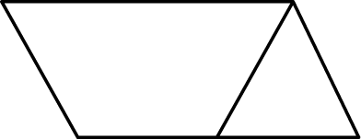 1. 2.

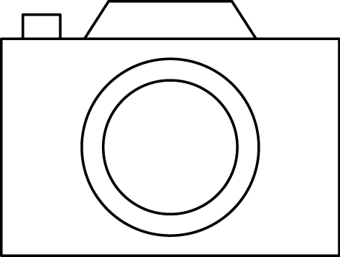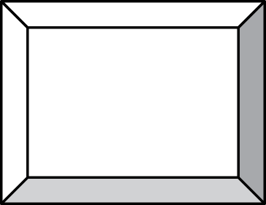 3. 4.

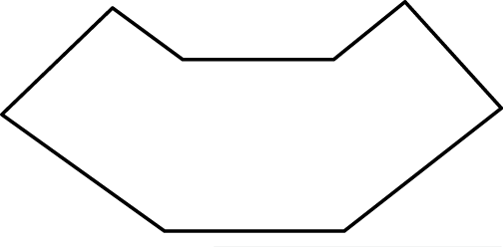 5. Identify the basic shapes that make up the top  
of your teacher’s desk.

BACK 🡪

Name Date

Fair Game Review **(continued)**

Chapter

13

Evaluate the expression.

6. 72 7. 112 8. 

9.  10.  11. 

12.  13. 

14. A kilometer is 103 meters. You run a 5-kilometer race. How many meters do you run?