Name: __________________________ Table #: _____________ Period: ______ Date: _________
13.1A NOTES – Circumference of Circles and Perimeter of Semicircles

Objective: use inductive reasoning to understand the formula for the circumference of a circle
CC.SS.7.G.4_MP4 Model with Mathematics
HW: 13.1A pg 553_#9-11, 13-19, 21

Circumference of Circles formula: ____________ Perimeter of Semi-circle formula: ____________

++++++++++++++++++++++++++++++++++++++++++++++++++++++++++++++++++++++++++++++++++++++++++++++

Use 3.14 for pi
- Find the circumference of the circle.  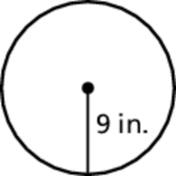 | - Find the circumference of the circle.  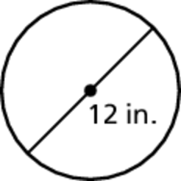
- Find the circumference of the circle.  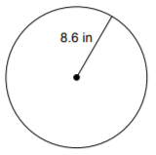 | - Find the circumference of the circle.  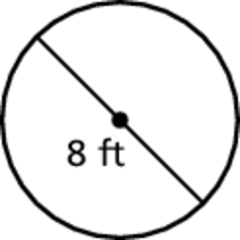
- Find the perimeter of the semicircle.  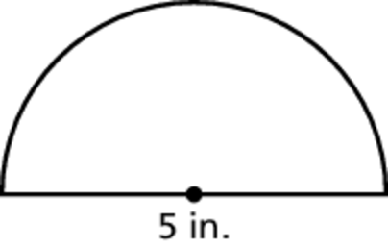 | - Find the perimeter of the semicircle.  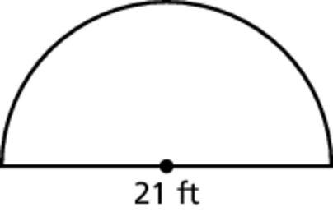
- Find the perimeter of the semicircular region. Round answer to the nearest tenth and use 3.14 for pi.  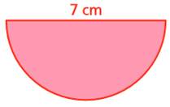 | - A wire is bent to form four semicircles. How long is the wire? Round to the nearest tenth and use 3.14 for pi.  24 cm  24 cm
BACK
EXAMPLE PROBLEMS
EXAMPLE 1: Consider the circles A, B, C, and D.
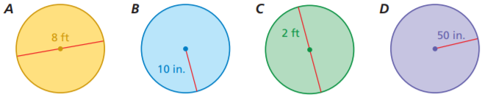
45 in
2.5 ft
9 in
4 ft
- Without calculating, which circle has the greatest circumference? ________________________________
- Without calculating, which circle has the least circumference? ___________________________________

EXAMPLE 2: A circular sinkhole has a circumference of 62.8 meters. A week later, it has a circumference of 188.4 meters.
- Estimate the diameter of the sinkhole each week. ___________________________________

- How many times greater is the diameter of the sinkhole now compared to the previous week?
____________________________

EXAMPLE 3: Find the circumference of both circles. Round answer to the nearest tenth and use 3.14 for pi.
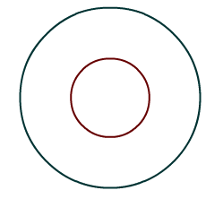
Small Circle | Big Circle

3 ft
1.5 ft

PRACTICE PROBLEMS
- Estimate the diameter given a circumference of 28.26 meters. | - Estimate the diameter given a circumference of 12.56 inches.
- Estimate the radius given a circumference of 28.26 meters. | - Estimate the radius given a circumference of 12.56 inches.

