Name: __________________________ Table #: _____________ Period: ______ Date: _________
13.3A NOTES – Areas of Circles and Semicirles

Objective: use inductive reasoning to understand the formula for the area of a circle
CC.SS.7.G.4_MP4 Model with Mathematics

Area of Circles formula: _____________________ Area of Semi-circle formula: _________________

++++++++++++++++++++++++++++++++++++++++++++++++++++++++++++++++++++++++++++++++++++++++++++++

Use 3.14 for pi
- Find the diameter of the circle.  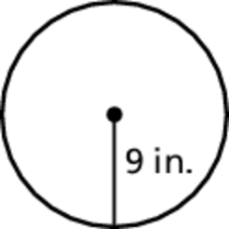 | - Find the radius of the circle.  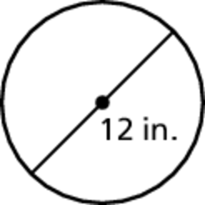
- Find the area of the circle. | - Find the area of the circle.  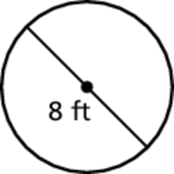
- Find the area of the semicircle.  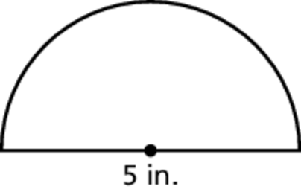 | - Find the area of the semicircle.  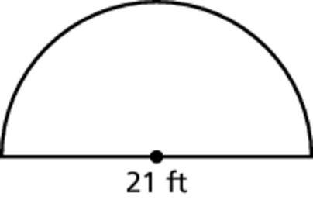

Problem 1: An FM radio station signal travels in a 40-mile radius. An AM radio station signal travels in a 4-mile radius. How much more area does the FM station cover than the AM station?

BACK

Problem 2: A dog is leashed to the corner of a house. How much running area does the dog have? Explain how you found your answer. (textbook: #17 pg 569)
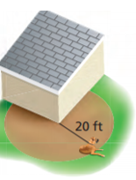

Problem 3: Find the area of the shaded region. Explain how you found your answer. (textbook: #19 pg 569)  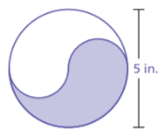 | Problem 4: Find the area of the shaded region. Explain how you found your answer. (textbook: #20 pg 569)  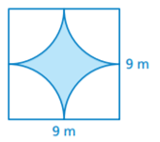

WARM-UP
Use order of operations and complete the following problems

- ${3(1+8)}^{2}$ | - ${2(3+7)}^{2}-3∙4$

