Name: ____________________Table:_______ Period: ____Date: ______
CH 3 Angle Relationships SBAC Practice_Classwork
Supplementary Angles (Sum is 180º)  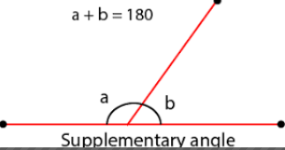 | Vertical Angles (CONGRUENT $≅$)  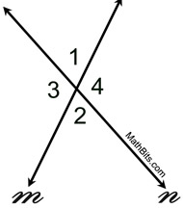
Sum of the interior angles of a polygon, S.  n = number of sides of the polygon  $$S= \left(n-2\right)∙180$$  EXAMPLE:  Hexagon (6 sides)  S = (6-2)∙ 180 = 720º | Sum of the exterior angles of a polygon  ALL POLYGONS EXTERIOR ANGLES’ SUM IS 360º  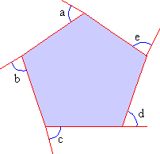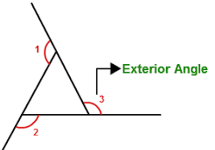

Chapter 3 Angle Review -- Identify the type of angles shown. Then write a brief description
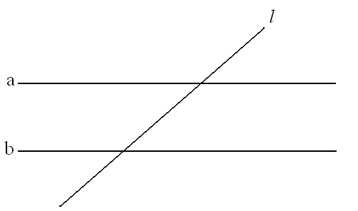  __________________________ angles | __________________________ angles
__________________________ angles | _________________________ angles
__________________________ angles | __________________________ angles

Describe 2 ways you can find the measure of Angle 5
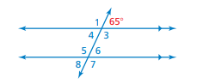
INTERIOR ANGLES AND EXTERIOR ANGLE MEASURES
Find the measures of the interior angles.  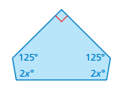 | Find the measure of the exterior angle  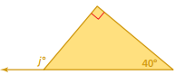
Can a pentagon have interior angles that measure 120º, 105º, 65 º, 150º, and 95º? Explain. | Find the measure of the exterior angles  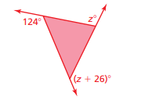
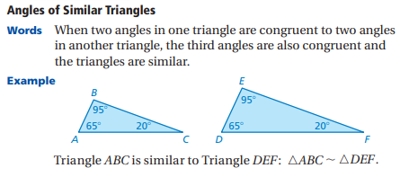

Are the triangles similar?  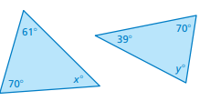 | Are the triangles similar?  