Name Date

SBAC PRACTICE 1 HW (Angle Relationships)

Use the figure to find the measure of 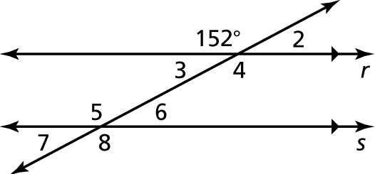

Answers

1.

See left.

2.

See left.

3.

See left.

4.

See left.

5.

6.

7.

8.

9.

10.

the angle. Explain your reasoning.

1. 

2. 

3. 

4. 

Find the measures of the interior angles.

5. 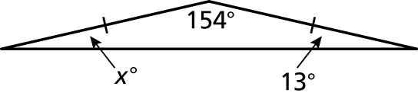 6. 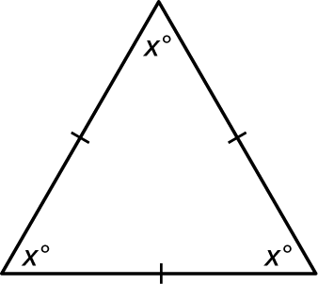

Find the measure of the exterior angle.

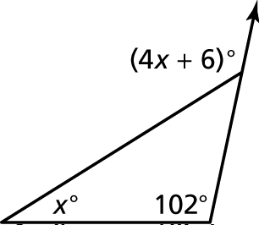 7. 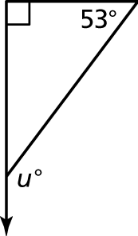 8.

Find the measures of the interior angles of the polygon.

9. 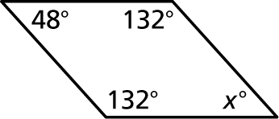 10. 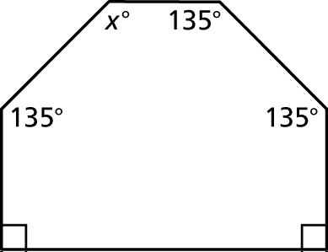

Name Date

**Find the** **measures of the exterior angles of the polygon.**

Answers

11.

12.

13.

14.

15. See left.

16.

17.

11. 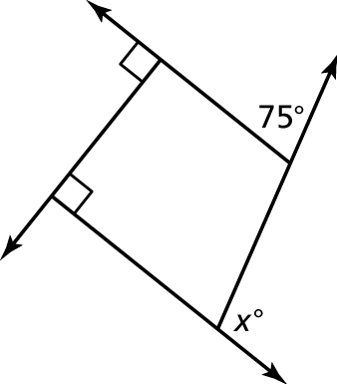 12. 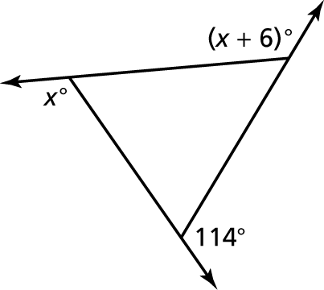

**Tell whether the triangles are similar. Explain.**

13. 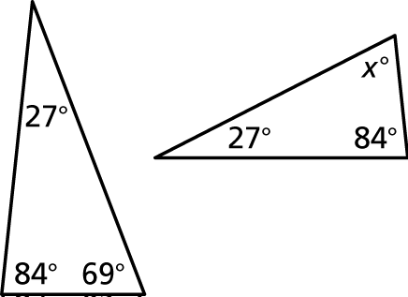 14. 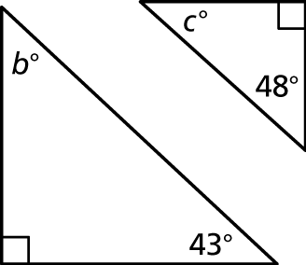

15. Describe two ways you can find   
the measure of 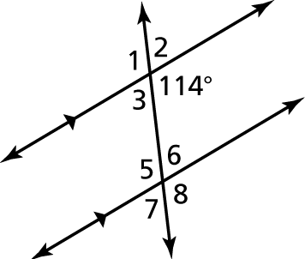

16. Can a hexagon have angles that measure   
and Explain.

17. You want to paddle a canoe across 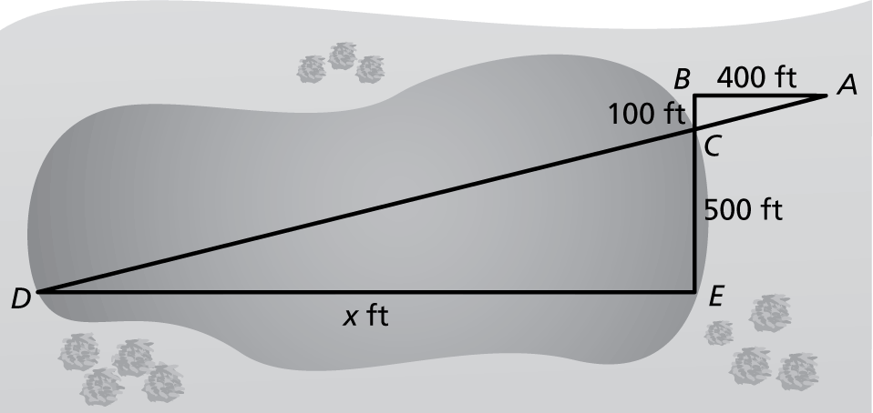a small lake and want to know how   
far it is to the other side. You take measurements on your side of the lake   
and make the drawing shown. What is the distance *x* across the lake?