Name Date

Translations 2.1-2.2 Review HW

2.2

Tell whether the shaded figure is a translation of the nonshaded figure.

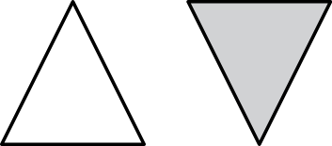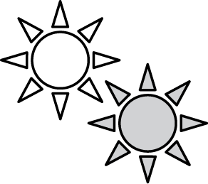 1. 2. 3.

4. Translate the figure 4 units left 5. Translate the triangle 5 units   
and 1 unit down. What are the right and 4 units up. What are   
coordinates of the image? the coordinates of the image?

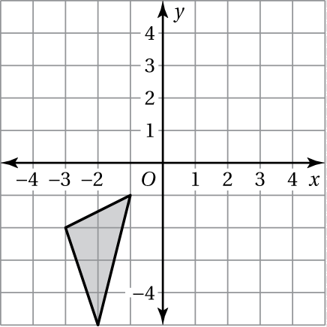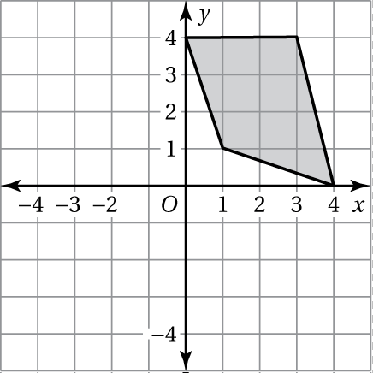

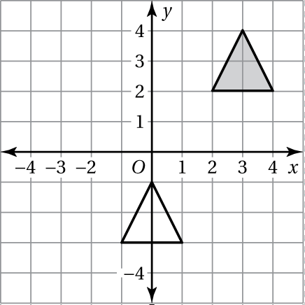 6. Describe the translation from the shaded figure  
to the nonshaded figure.

**BACK 🡪**

Name Date

**Reflections**

2.3

Tell whether the shaded figure is a reflection of the nonshaded figure.

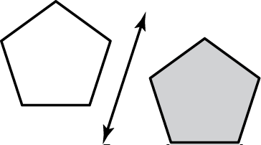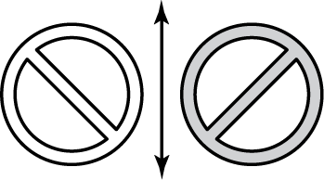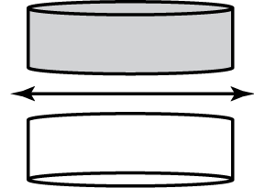 1. 2. 3.

Draw the figure and its reflection in the *x*-axis. Identify the coordinates of the image.

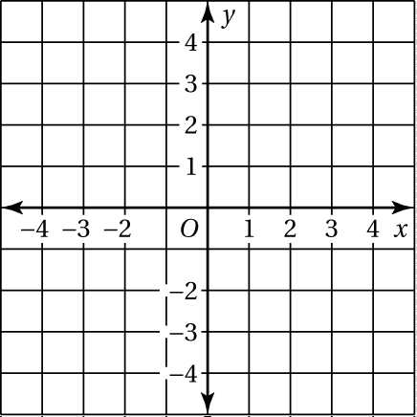 4. ** 5. **

A’: B’: C: W’: X’:

Y’: Z’:

Draw the figure and its reflection in the *y*-axis. Identify the coordinates of the image.

 6. ** 7. **

J’: K’: L’: M’: N’:

P’: Q’: