Name: _______________________________ Table #: ______ Period: _____ Date: ________
2.1A Congruent Figures_Classwork
Objective: Name corresponding angles and sides of congruent figures. Identify congruent figures. Use congruency marks. CCSS: Preparing for 8.G.2
HW: (2.1) p. 46 #4 - 9, 11, 12, 15 (copy the figures in #6 – 9) -- solutions on p. A12
Solutions to #12a) 32 ft b) $\text{∠M}$ c) 20 ft. d) 96 ft.
- Review 2.1 Vocabulary words (congruent figures, corresponding angles, corresponding sides)
- READ 2.1 (p. 44-45).
- Do Examples 1, 2 and 3 below.
- WATCH BIG IDEAS MATH VIDEOS: Chapter 2, Section 2.1, Examples 1, 2, and 3 to check your answers.
Login to bigdieasmath.com. Go to APPS. Select “web” from BIG IDEAS MATH VIDEOS. Select “Common Core Middle School 2017.” Select our textbook. Chapter 2, Section 2.1, Examples 1, 2, & 3
2.1, Ex. 1. The figures are congruent. Name the corresponding angles and corresponding sides.
 | Corresponding Angles | Corresponding Sides

2.1, Ex.2.  Tell whether the two figures are congruent. Explain your reasoning.  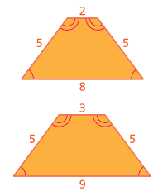 | 2.1, Ex. 3  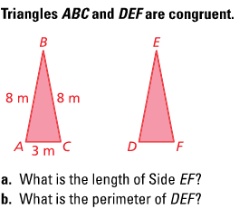

Identifying Congruent Figures
Two figures are congruent when ___________________ ____________ and ___________________ ____________ are congruent. Triangle ABC is congruent to Triangle DEF.
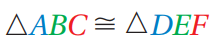

 | Corresponding Angles | Corresponding Sides

- Use Congruency marks to show the 2 pentagons are congruent. | - Trapezoids ABCD & EFGH are congruent.  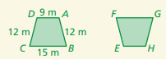  - What is the length of FG?  - What is the perimeter of Trapezoid EFGH?

- Are these figures congruent? How do you know? EXPLAIN
- b)
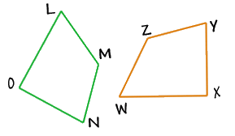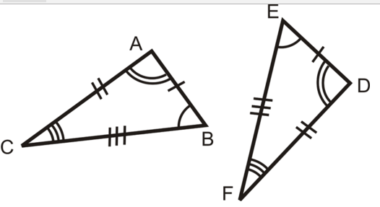

- Two figures are congruent. Answer the following problems.
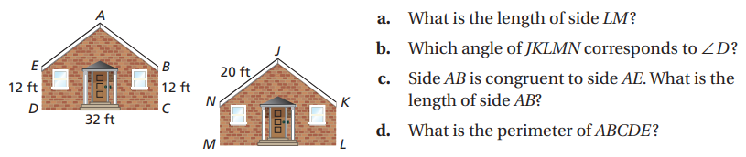

Name: _____________________ Table# ____ Period ___ Exit Slip (2.1)

- Draw a triangle.
- Draw a second triangle that is congruent to it.
- Mark the corresponding sides and corresponding angles of the congruent figures.

