Name: _______________________________ Table #: ______ Period: _____ Date: ________
2.1A NOTES – Congruent Figures
Objective: Name corresponding angles and sides of congruent figures. Identify congruent figures. Use congruency marks. CCSS: Preparing for 8.G.2
HW: (2.1) p. 46 #4 - 9, 11, 12, 15 (copy the figures in #6 – 9)

Identifying Congruent Figures
Two figures are congruent when _____________________ ____________ and ___________________ ____________ are congruent. Triangle ABC is congruent to Triangle DEF.
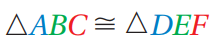

 | Corresponding Angles | Corresponding Sides

You cannot assume two shapes are congruent if there are no _______________________ ____________ or _________________________ ________________.

2.1, Ex. 1. The figures are congruent. Name the corresponding angles and corresponding sides.
 | Corresponding Angles | Corresponding Sides

2.1, Ex.2.  Tell whether the two figures are congruent. Explain your reasoning.  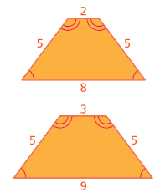 | 2.1, Ex. 3  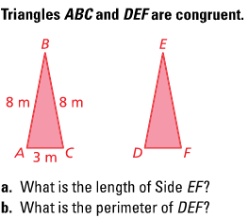

BACK
ON YOUR OWN
- Use Congruency marks to show the 2 pentagons are congruent. | - Trapezoids ABCD & EFGH are congruent.  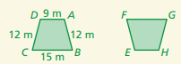  - What is the length of FG?  - What is the perimeter of Trapezoid EFGH?

- Are these figures congruent? How do you know? EXPLAIN
- b)
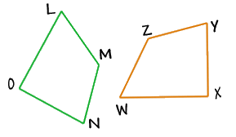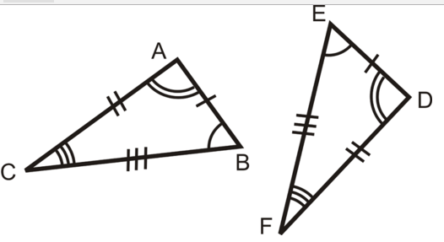

- Two figures are congruent. Answer the following problems.
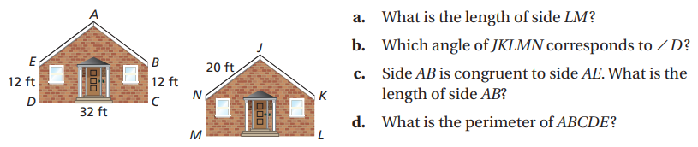

++++++++++++++++++++++++++++++++++++++++++++++++++++++++++++++++++++++++++++++++++++++
Name: _____________________ Table# ____ Period ___ Exit Slip (2.1)
- Draw a triangle.
- Draw a second triangle that is congruent to it.
- Mark the corresponding sides and corresponding angles of the congruent figures.

