Name: ___________________ Table #: __________ Period: ______ Date: _____
2.1B Rational Numbers_Classwork
Objective: understand that a rational number is an integer divided by an integer, convert rational numbers to decimals. CC.SS.7.NS.2b, CC.SS.7.NS.2d
HW: textbook- 2.1B page 48_#3-18 ALL
Write the rational number as a decimal
$-\frac{1}{12}$= | $$2\frac{2}{5}=$$ | $-1\frac{1}{8}$= | $$\frac{2}{3}=$$

Order the numbers from least to greatest
- $1\frac{1}{5}, -\frac{4}{7}, \frac{3}{8}$ | - $-\frac{3}{4}, -\frac{4}{5}, 2\frac{1}{4}$

Ordering Rational Numbers
The table shows the elevations of four sea creates relative to sea level. Which of the sea creatures are deeper than the whale? Explain.

Ordering Rational Numbers
The table shows the changes from the average water level of a pond over several weeks. Order the numbers from least to greatest.

WARM-UP
Direction: Determine each problem if it is a rational number, integer, whole number, natural number, terminating decimal, or repeating decimal. Each value can have more than one answer.
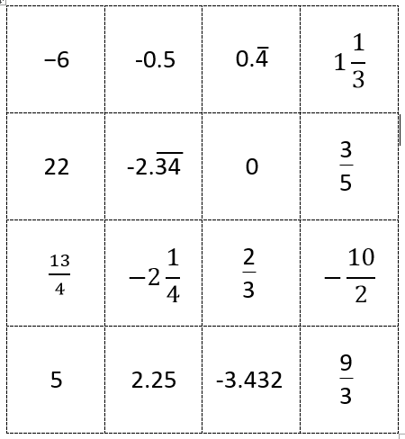

Name: _________________________

