Name: ____________________________________ Table #: __________ Period: ______ Date: _____
2.1C Rational Numbers_Classwork
Objective: understand that a rational number is an integer divided by an integer, convert rational numbers to decimals. CC.SS.7.NS.2b, CC.SS.7.NS.2d
HW: textbook- 2.1C page 48_#24-30 ALL, #36-41 ALL
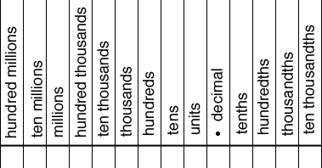
Write the decimal as a fraction or a mixed number in simplest form
-0.7 = | 0.125 = | -1.12 = | 0.75 =
-0.3 = | 0.355 = | -1.45 = | 0.65 =

Order the numbers from least to greatest
- $-\frac{4}{5}, \frac{2}{3}, 0.75, -0.8$ | - $-\frac{3}{4}, -2\frac{1}{5}, -2.25,- 1.3$
- $-\frac{3}{8}, -1\frac{3}{10}, -0.2, -0.95$ | - $1\frac{7}{10}, \frac{1}{3}, -0.15, -2.8$

WARM-UP
One the diagram provided color in the decimal fractions
Problems | Color
- 0.7

- 0.9

- 0.4

- 0.25

Write each of the following as a simplified fraction and draw a diagram to represent each rational number.
Example:
$\frac{113}{100}=\frac{100}{100}+\frac{13}{100}=1+\frac{13}{100}=1\frac{13}{100}$

- $\frac{20}{100}$

- $\frac{70}{100}$

- $\frac{150}{100}$

- $\frac{225}{100}$

