Name: ___________________ Table #: ______ Period: ______ Date: ______

2.2A NOTES – Translations
Objective: identify translations; translate figures in the coordinate plane. CC.SS.8.G.1/G.2/G.3
MP3 Construct Viable Argument HW: 2.2A pg 52 #7-20 all

- A transformation changes a figure into another figure. The new figure is called the ________.
- A translation is a transformation in which a figure ____________. Every point of the figure moves the __________ distance and in the __________ direction.
- PREIMAGE is the _________________ figure in the transformation.
- IMAGE is the ___________ figure in the transformation.
A’ is read “A prime” Use prime symbols when naming an image. | A ↦ A’  B ↦ B’  C ↦ C’

Summary of Translations
Operations | Translations | Notations
Add to X | Move to the RIGHT | (x, y) ↦ (x + #, y)
Subtract from X | Move to the LEFT | (x, y) ↦ (x – #, y)
Add to Y | Move UP | (x, y) ↦ (x, y + #)
Subtract from Y | Move DOWN | (x, y) ↦ (x, y – #)

DIRECTIONS: Tell whether the blue figure is a translation of the red figure. EXPLAIN.
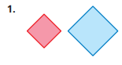  B  R | 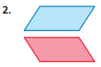  B  R | 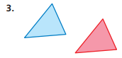  B  R

Chapter 2, Section 2.2, EXAMPLE 1  Translate Triangle ABC 2 units right and 5 units up. What are the coordinates of the image?  Identify the coordinate notation.  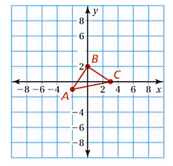 | ON YOUR OWN #4  The vertices of a triangle are A(-2, 1), B(2, 5), C(1, 2). Translate Triangle ABC 4 units left and 2 units down. What are the coordinates of the image?  Identify the coordinate notation.  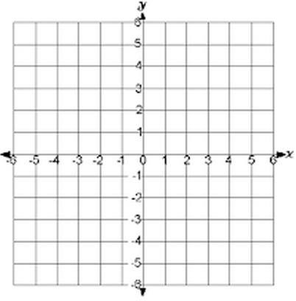
BACK
1. translation: 2 units left and 2 units down  Notation Rule: (x, y) ↦ ( _______, _______)  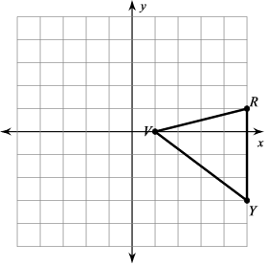  V:  R:  Y:  V’:  R’:  Y’: | 2. translation: 1 unit right and 1 unit down  Notation Rule: (x, y) ↦ ( _______, _______)  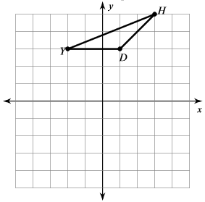  D:  H:  Y:  D’:  H’:  Y’:
3. translation: 6 units right and 5 units down  Notation Rule: (x, y) ↦ ( _______, _______)  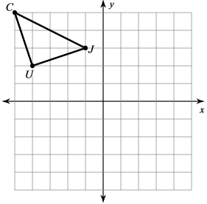  C:  J:  U:  C’:  J’:  U’: | 4. translation: 3 units left  Notation Rule: (x, y) ↦ ( _______, _______)  B:  R:  M:  Q:  B’:  R’:  M’:  Q’:  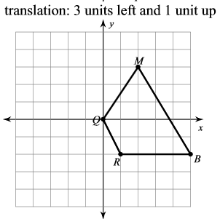
5. Create your own translation: Provide a rule. Graph the Pre-Image and Image.  Written Rule: ____________________________  Notation Rule: ___________________________  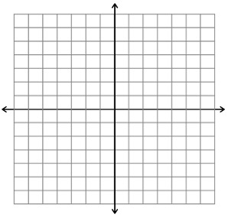 | 6. Create your own translation: Provide a rule. Graph the Pre-Image and Image.  Written Rule: ____________________________  Notation Rule: ___________________________
YouTube video with all transformations
https://www.youtube.com/watch?v=VJTxv-tRKj0

