Name: ___________________ Table #: ______ Period: ______ Date: ______

2.2A Translations_Classwork
Objective: identify translations; translate figures in the coordinate plane. CC.SS.8.G.1/G.2/G.3
MP3 Construct Viable Argument
HW: 2.2A worksheet
- A transformation changes a figure into another figure. The new figure is called the _________.
- A translation is a transformation in which a figure ____________ but does not _____________. Every point of the figure moves the same distance and in the same direction.
- PREIMAGE is the ____________________ figure in the transformation.
- IMAGE is the ________________________ figure in the transformation.
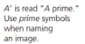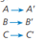
Summary of Translations
Operations | Translations | Notations
Add to X | Move to the ____________ | (x, y) ↦ (x + #, y)
Subtract from X | Move to the ____________ | (x, y) ↦ (x – #, y)
Add to Y | Move ____________ | (x, y) ↦ (x, y + #)
Subtract from Y | Move ____________ | (x, y) ↦ (x, y – #)

WATCH BIG IDEAS MATH VIDEO: Chapter 2, Section 2.2, Example 1

EXAMPLE: Translate Triangle ABC 3 units right and 3 units down. What are the coordintates of the image? A(-2, 1), B(2, 5), C(1, 2)
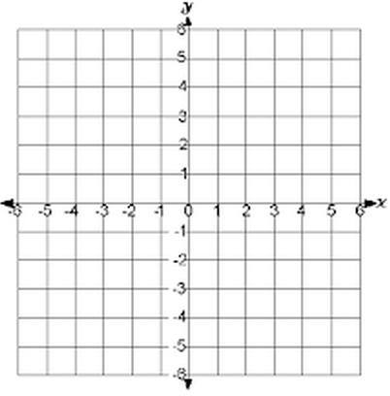

1. translation: 2 units left and 2 units down  (x, y) _________________________  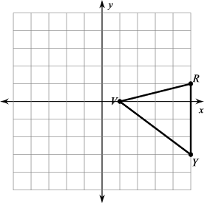  V:  R:  Y:  V’:  R’:  Y’: | 2. translation: 1 unit right and 1 unit down  (x, y) _________________________  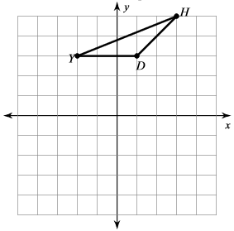  D:  H:  Y:  D’:  H’:  Y’:
3. translation: 6 units right and 5 units down  (x, y) _________________________  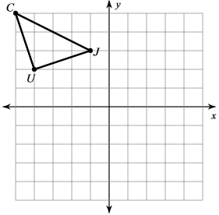  C:  J:  U:  C’:  J’:  U’: | 4. translation: 3 units left  (x, y) _________________________  B:  R:  M:  Q:  B’:  R’:  M’:  Q’:  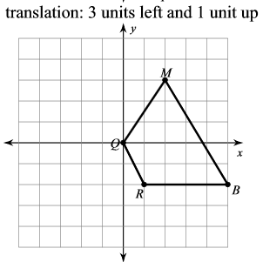
5. Create your own translation: Provide a rule. Graph the Pre-Image and Image.  Written Rule: ____________________________  Notation Rule: ___________________________  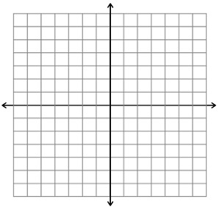 | 6. Create your own translation: Provide a rule. Graph the Pre-Image and Image.  Written Rule: ____________________________  Notation Rule: ___________________________
YouTube video with all transformations
https://www.youtube.com/watch?v=VJTxv-tRKj0

