Name: ___________________ Table #: ______ Period: ______ Date: ______

**2.2B Translations_Classwork**

*Objective: identify translations; translate figures in the coordinate plane. CC.SS.8.G.1/G.2/G.3*

*HW: 2.2B pg 52_#7-20 ALL*

**Summary of Translations**

|  |  |  |
| --- | --- | --- |
| **Operations** | **Translations** | **Notations** |
| Add to X | Move to the RIGHT | (x, y) ↦ (x + #, y) |
| Subtract from X | Move to the LEFT | (x, y) ↦ (x – #, y) |
| Add to Y | Move UP | (x, y) ↦ (x, y + #) |
| Subtract from Y | Move DOWN | (x, y) ↦ (x, y – #) |

***Describe each transformation in words.***

|  |  |
| --- | --- |
| 1. (x,y)🡪(x + 10, y) | 10 units to the RIGHT |
| 1. (x,y)🡪( (x – 5, y ) |  |
| 1. (x,y)🡪( (x, y + 7) |  |
| 1. (x,y)🡪( (x, y – 6) |  |
| 1. (x,y)🡪( (x + 3, y – 7) |  |
| 1. (x,y)🡪( (x – 3, y – 7) |  |
| 1. (x,y)🡪( (x + 5, y + 8) |  |

|  |  |
| --- | --- |
| **EXAMPLE 1:**  Δ*ABC* is translated 1 unit right and 4 units up. Draw the image Δ*A’B’C’*. | What are the coordinates of:  *A* (1, -3) ↦ *A’* _________  *B* (3, 0) ↦ *B’* _________  *C*  (4, -2) ↦ *C’*__________  From EXAMPLE 1, *ΔABC* ↦ *ΔA’B’C’*  As a general rule this translation could be written as: (*x, y*) ↦ (*x* + ___, *y* + ___). |
| **EXAMPLE 2:**  Δ*JKL* has coordinates:  *J* (0, 2), *K* (3, 4), and *L* (5, 1).   1. Draw Δ*JKL*. 2. Draw the image Δ*J’K’L’* after a translation of 4 units to the left and 5 units up. Label the triangle.   Image result for graphing | *J*  (0, 2) ↦ *J’* _________  *K* (3, 4) ↦ *K’* _________  *L* (5, 1) ↦ *L’*__________  Rule: (*x*, *y*) ↦ ( , )  Tell me more about this figure, is it congruent or similar? Explain how you know. |

|  |  |
| --- | --- |
| **EXAMPLE 3:**  Write a general rule which describes the translation shown below. Δ*LMN* is the original triangle.  M = L = N =  M’ = L’ = N’ = | (*x, y*) ↦ ( , ) |

|  |  |  |
| --- | --- | --- |
| **EXAMPLE 4 (textbook #21):**   |  |  | | --- | --- | |  | A school of fish translates from point F to point D.   1. Describe the translation of the school of fish. 2. Can the fishing boat make the same translation? Explain. 3. Describe a translation the fishing boat could make to get to point D. | |

Name: ______________________________________ Table# ____ Period _______ EXIT SLIP

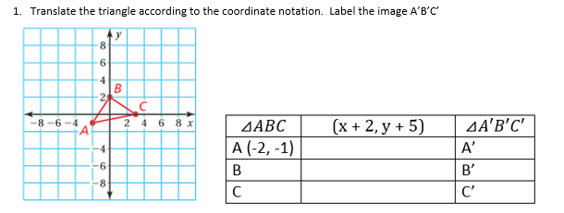

Name: ______________________________________ Table# ____ Period _______ EXIT SLIP



Name: ______________________________________ Table# ____ Period _______ EXIT SLIP



You tube video with all transformations

<https://www.youtube.com/watch?v=VJTxv-tRKj0>

You Tube video with dinosaurs

<https://www.youtube.com/watch?v=NY2cDTpsvBA>