Name: ___________________________________________ Per ______ Date __________
2.3A Textbook HOMEWORK
page 58_ #1 –19 ODD (solutions on p. A13)
DON’T FORGET TO “IDENTIFY THE COORDINATES OF THE IMAGE”

1. ______________

3. 5. ____________ 7. ____________ 9. ___________
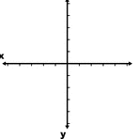
11. 13.
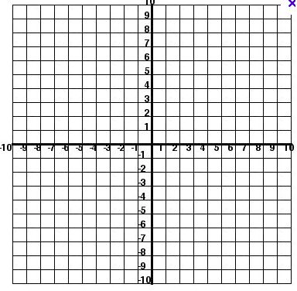

15. 17.

19. ______________________________

