Name: _____________________ Table#: ________ Period: ________ Date: ______
2.3A Reflections_Classwork

Objective: Identify reflections. Reflect figures in the x-axis or the y-axis of the coordinate place. CCSS: 8.G.1, 2 and 3
HW: (2.3A) p. 58 #1 – 19 ODD – use handout (solutions on p. A13)

A reflection or _________________________ is a transformation in which a figure is reflected in a line called the
____________________ of _________________________. A reflection creates a _________________________ ____________________________ of the original figure.
Tell whether the blue figure is a reflection of the red figure. Explain.
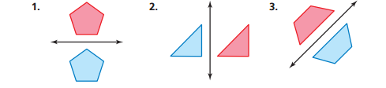

Example 1: Reflecting a Figure in the x-axis  The vertices of a triangle are A(-1,1), B(-1,3), and C(6,3). Draw the figure and its reflection in the x-axis.  A’  B’  C’ | Example 2: Reflecting a Figure in the y-axis  The vertices of a quadrilateral are P(-2,5), Q(-1,-1), R(-4,2), and S(-4,4). Draw the figure and its reflection in the y-axis.  P’  Q’  R’  S’
- Reflect triangle ABC in the x-axis.  A(-1,3), B(2,4), C(0,5)  A’  B’  C’ | - Reflect triangle ABC in the y-axis.  A(-1,3), B(2,4), C(0,5)  A’  B’  C’
- Record the coordinates of $⊿EFG$and $⊿E^{'}F^{'}G^{'}.$ Do you notice a pattern? What happens to the coordinates of the original figure when they are reflected over the x-axis?  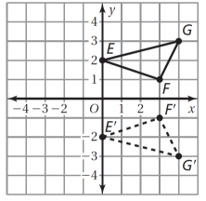  E ( ) E’ ( )  F ( ) F’ ( )  G ( ) G’ ( )  Notation Rule: (x,y) | - The vertices of a parallelogram are A(-1, -1), B(2, -1), C(4,-3), and D(1,-3). Draw the figure and its reflection in the x-axis. What are the coordinates of the images?  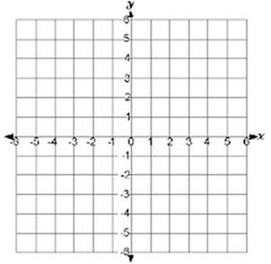  A’: B’: C’: D’:  Notation Rule: (x,y)
- Record the coordinates of $⊿JKL$and $⊿J^{'}K^{'}L^{'}.$ Do you notice a pattern? What happens to the coordinates of the original figure when they are reflected over the y-axis?  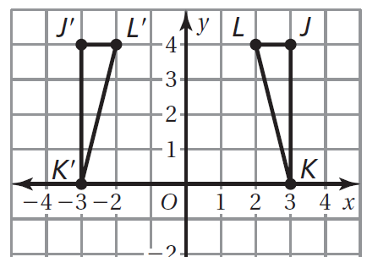  J ( ) J’ ( )  K ( ) K’ ( )  L ( ) L’ ( )  Notation Rule: (x,y) | - The vertices of a triangle are A(1,-2), B(4,-2), and C(1,4). Draw the figure and its reflection in the y-axis. Identify the coordinates of the image.  A’: B’: C’:  Notation Rule: (x,y)

- Problem similar to #3 on the 2.3A HW  A figure lies entirely in Quadrant III. If you reflect it in the y-axis, in which quadrant is the image? | 