Name: ___________________________________________ Per ______ Date __________

**2.3A Textbook HW**

page 58_ #1 –19 ODD (solutions on p. A13)

DON’T FORGET TO “IDENTIFY THE COORDINATES OF THE IMAGE”

1. ______________

3. 5. ____________ 7. ____________ 9. ___________

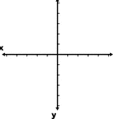

11. 13.

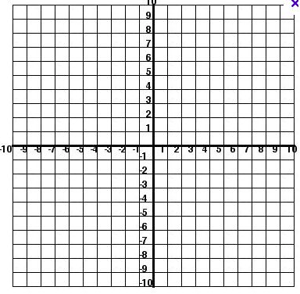 

15. 17.

 

19. ______________________________