Name: ______________________ Table #: ______ Period: _______ Date: ______
2.3B Multiple Transformations_ Classwork
OBJECTIVE: Identify reflections. Reflect figures in the x-axis or the y-axis of the coordinate place. CCSS: 8.G.1, 2 and 3

1.  $$Translate ΔALT if A\left(-5,-1\right), L\left(-3,-2\right), T\left(-3,2\right)$$  $$by the rule 6 units right and 3 units down, then$$  $reflect the$ $image over the y-axis.$  A’: L’: T’:  A’’: L’’: T’’: | 2.  $$Reflect ΔTAB if T\left(2,3\right), A\left(1,1\right), and B\left(4,-3\right)over the$$  $$x-axis, then reflect the image over the y-axis.$$  T’: A’: B’:  T’’: A’’: B’’:
3.  $$Reflect ΔCAB if C\left(2,3\right), A\left(0,1\right), and B\left(4,-3\right) over$$  $$the y-axis, then translate the image by the rule$$  $$\left(x,y\right)→\left(x+3, y-4\right).$$  C’: A’: B’:  C’’: A’’: B’’: | 4.  $$Translate ΔEAT if E\left(1,3\right), A\left(2,1\right), and T\left(3, 3\right) by$$  $$the rule 4 units up, then reflect the image over the$$  $$x-axis.$$  E’: A’: T’:  E’’: A’’: T’’:
5.  The coordinates of a point and its image are given. Is the reflection in the x-axis or the y-axis? Explain.  (-8, 3) (8, 3) | 6.  The coordinates of a point and its image are given. Is the reflection in the x-axis or the y-axis? Explain.  (-2, 4) (-2, -4)
7.  Identify and write a rule for the transformations.  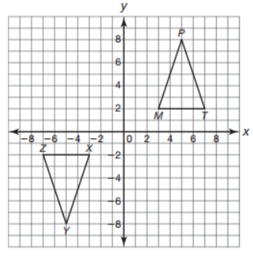(x, y)  PRE-IMAGE  IMAGE | 8.  Identify and write a rule for the transformations.  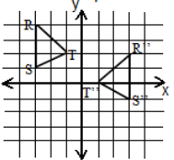 x, y)

Practice Problems- textbook: page 59 #19-24
- The coordinates of a point and its image are given. Is the reflection in the x-axis or the y-axis? Explain.  (2, -2) (2, 2) | - The coordinates of a point and its image are given. Is the reflection in the x-axis or the y-axis? Explain.  (-4, 1) (4, 1)
- The coordinates of a point and its image are given. Is the reflection in the x-axis or the y-axis? Explain.  (-2, -5) (2, -5) | - The coordinates of a point and its image are given. Is the reflection in the x-axis or the y-axis? Explain.  (-3, -4) (-3, 4)
- Find the coordinates of the figure after the transformation: Translate the triangle 1 unit right and 5 units down. Then reflect the image in the y-axis  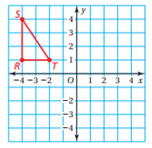  S’: T’: R’:  S’’: T’’: R’’: | - Find the coordinates of the figure after the transformations: Reflect the trapezoid in the x-axis. Then translate the trapezoid 2 units left and 3 units up.  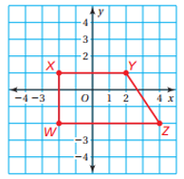  X’: Y’: Z’: W’:  X’’: Y’’: Z’’: W’’:

