Name: ____________________ Table #: _______ Period: _____ Date: ____
2.4A NOTES – Rotations (1)
OBJECTIVE: rotate the figures 90 degrees clockwise, 180 degrees, 270 degrees clockwise, 90 degrees counterclockwise about the origin. CCSS: 8.G.1, 2 and 3

Record the Pre-Image and Image coordinate pairs for each problem.

WRITTEN RULE: Rotate 90 degrees counterclockwise about the origin
1.  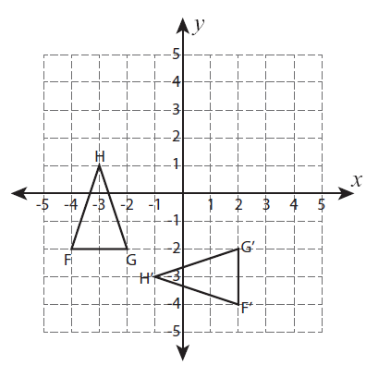  F (-4, -2) F’ (2, -4)  G (-2, -2) G’ (2, -2)  H (-3, 1) H’ (-1, -3) | 2.  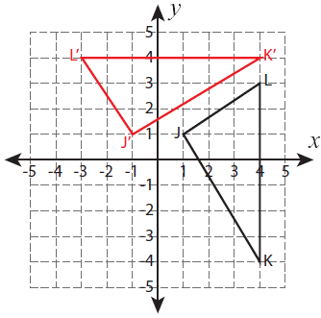  J (1, 1) J’ (-1, 1)  K (4, -4) K’ (4, 4)  L (4, 3) L’ (-3, 4) | 3.  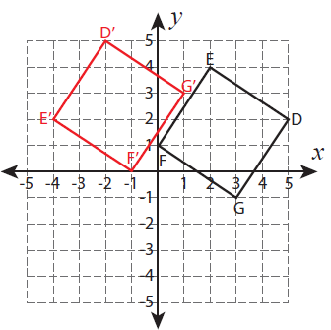  D (5, 2) D’ (-2, 5)  E (2, 4) E’ (-4, 2)  F (0, 1) F’ (-1, 0)  G (3, -1) G’ (1, 3)

Do you notice a pattern? What happens to the coordinates of the Pre-Image when they are rotated about the origin?
Your Finding: Rotate 90 degrees counterclockwise about the origin

______________’s Finding: Rotate 90 degrees clockwise about the origin

______________’s Finding: Rotate 270 degrees clockwise about the origin

______________’s Finding: Rotate 180 degrees about the origin

BACK
Name: ____________________ Table #: _______ Period: _____ Date: ____
2.4A NOTES – Rotations (2)
OBJECTIVE: rotate the figures 90 degrees clockwise, 180 degrees, 270 degrees clockwise, 90 degrees counterclockwise about the origin. CCSS: 8.G.1, 2 and 3

Record the Pre-Image and Image coordinate pairs for each problem.

WRITTEN RULE: Rotate 90 degrees clockwise about the origin
1.  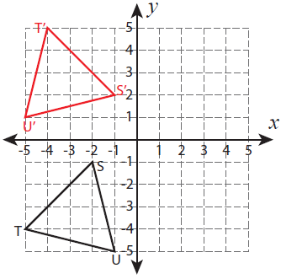  S (-2, -1) S’ (-1, 2)  U (-1, -5) U’ (-5, 1)  T (-5, -4) T’ (-4, 5) | 2.  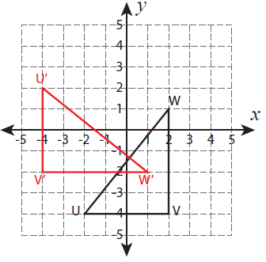  U (-2, -4) U’ (-4, 2)  W (2, 1) W’ (1, -2)  V (2, -4) V’ (-4, -2) | 3.  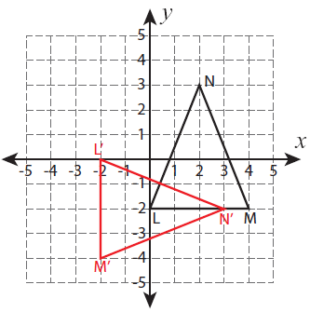  L (0, -2) L’ (-2, 0)  M (4, -2) M’ (-2, -4)  N (2, 3) N’ (3, -2)

Do you notice a pattern? What happens to the coordinates of the Pre-Image when they are rotated about the origin?
Your Finding: Rotate 90 degrees clockwise about the origin

______________’s Finding: Rotate 90 degrees counterclockwise about the origin

______________’s Finding: Rotate 270 degrees clockwise about the origin

______________’s Finding: Rotate 180 degrees about the origin

BACK
Name: ____________________ Table #: _______ Period: _____ Date: ____
2.4A NOTES – Rotations (3)
OBJECTIVE: rotate the figures 90 degrees clockwise, 180 degrees, 270 degrees clockwise, 90 degrees counterclockwise about the origin. CCSS: 8.G.1, 2 and 3

Record the Pre-Image and Image coordinate pairs for each problem.

WRITTEN RULE: Rotate 270 degrees clockwise about the origin
1.  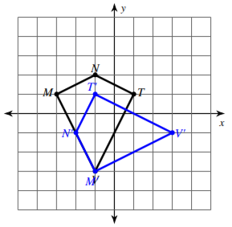  M (-3, 1) M’ (-1, -3)  N (-1, 2) N’ (-2, -1)  T (1, 1) T’ (-1, 1)  V (-1, -3) V’ (3, -1) | 2.  J (1, 1) J’ (-1, 1)  K (4, -4) K’ (4, 4)  L (4, 3) L’ (-3, 4) | 3.  D (5, 2) D’ (-2, 5)  E (2, 4) E’ (-4, 2)  F (0, 1) F’ (-1, 0)  G (3, -1) G’ (1, 3)

Do you notice a pattern? What happens to the coordinates of the Pre-Image when they are rotated about the origin?
Your Finding: Rotate 270 degrees clockwise about the origin

______________’s Finding: Rotate 90 degrees clockwise about the origin

______________’s Finding: Rotate 90 degrees counterclockwise about the origin

______________’s Finding: Rotate 180 degrees about the origin

BACK
Name: ____________________ Table #: _______ Period: _____ Date: ____
2.4A NOTES – Rotations (4)
OBJECTIVE: rotate the figures 90 degrees clockwise, 180 degrees, 270 degrees clockwise, 90 degrees counterclockwise about the origin. CCSS: 8.G.1, 2 and 3
Record the Pre-Image and Image coordinate pairs for each problem.

WRITTEN RULE: Rotate 180 degrees about the origin
1.  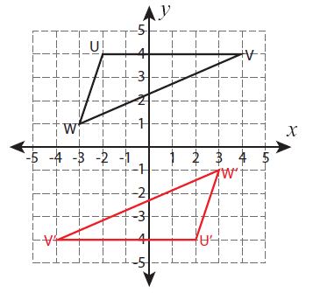  U (-2, 4) U’ (2, -4)  V (4, 4) V’ (-4, -4)  W (-3, 1) W’ (3, -1) | 2.  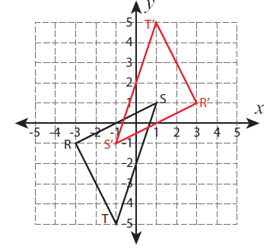  T (-1, -5) T’ (1, 5)  R (-3, -1) R’ (3, 1)  S (1, 1) S’ (-1, -1) | 3.  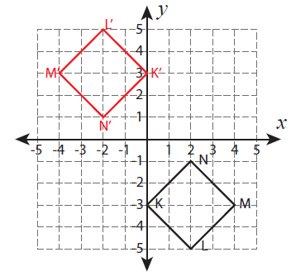  K (0, -3) K’ (0, 3)  L (2, -5) L’ (-2, 5)  M (4, -3) M’ (-4, 3)  N (2, -1) N’ (-2, 1)

Do you notice a pattern? What happens to the coordinates of the Pre-Image when they are rotated about the origin?
Your Finding: Rotate 180 degrees about the origin

______________’s Finding: Rotate 90 degrees clockwise about the origin

______________’s Finding: Rotate 270 degrees clockwise about the origin

______________’s Finding: Rotate 90 degrees counterclockwise about the origin

BACK
Find the ordered pair after the designated rotation about the origin.
1.  Rotate A(3, -5) 90º clockwise about the origin  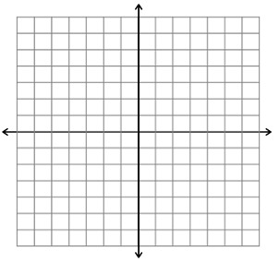 | 2.  Rotate A(3, -5) 180º about the origin. | 3.  Rotate A(3, -5) 90º counterclockwise about the origin.
4.  Rotate B(2, 4) 90º clockwise about the origin | 5.  Rotate B(2, 4) 180º about the origin. | 6.  Rotate B(2, 4) 90º counterclockwise about the origin.
4.  Rotate C(-1, 6) 90º clockwise about the origin | 5.  Rotate C(-1, 6) 180º about the origin. | 6.  Rotate C(-1, 6) 90º counterclockwise about the origin.
HW: (2.4A) p. 65 #2 – 5, 7-14, 30-33

