Name: ____________________ Table #: _______ Period: _____ Date: ____
2.4A Rotations_Classwork (1)
OBJECTIVE: rotate the figures 90 degrees clockwise, 180 degrees, 270 degrees clockwise, 90 degrees counterclockwise about the origin. CCSS: 8.G.1, 2 and 3

Record the Pre-Image and Image coordinate pairs for each problem.

Rotate 90 degrees counterclockwise about the origin
1.  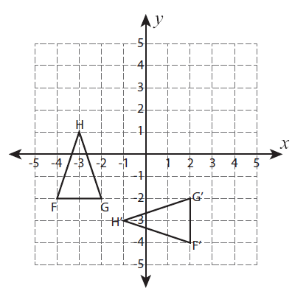  F F’  G G’  H H’ | 2.  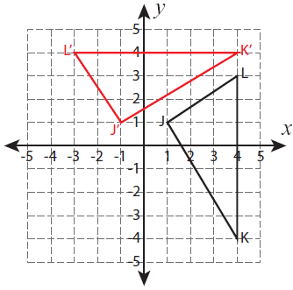  J J’  K K’  L L’ | 3.  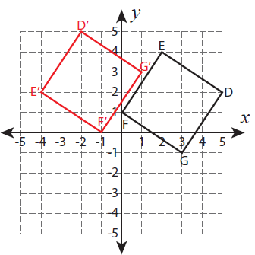  D D’  E E’  F F’  G G’

Do you notice a pattern? What happens to the coordinates of the Pre-Image when they are rotated about the origin?
Your Finding:

______________’s Finding: RULE: ________________________________________________________

______________’s Finding: RULE: ________________________________________________________

______________’s Finding: RULE: ________________________________________________________

Name: ____________________ Table #: _______ Period: _____ Date: ____
2.4A Rotations_Classwork (2)
OBJECTIVE: rotate the figures 90 degrees clockwise, 180 degrees, 270 degrees clockwise, 90 degrees counterclockwise about the origin. CCSS: 8.G.1, 2 and 3

Record the Pre-Image and Image coordinate pairs for each problem.

Rotate 90 degrees clockwise about the origin
1.  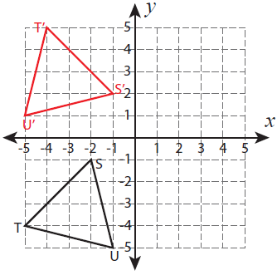  S S’  U U’  T T’ | 2.  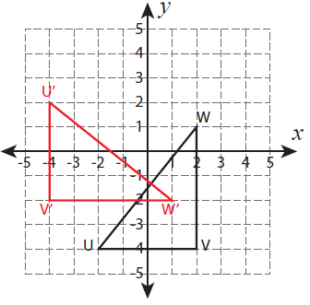  U U’  W W’  V V’ | 3.  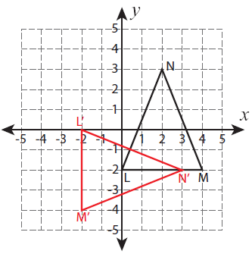  L L’  M M’  N N’

Do you notice a pattern? What happens to the coordinates of the Pre-Image when they are rotated about the origin?
Your Finding:

______________’s Finding: RULE: ________________________________________________________

______________’s Finding: RULE: ________________________________________________________

______________’s Finding: RULE: ________________________________________________________

Name: ____________________ Table #: _______ Period: _____ Date: ____
2.4A Rotations_Classwork (3)
OBJECTIVE: rotate the figures 90 degrees clockwise, 180 degrees, 270 degrees clockwise, 90 degrees counterclockwise about the origin. CCSS: 8.G.1, 2 and 3

Record the Pre-Image and Image coordinate pairs for each problem.

Rotate 270 degrees clockwise about the origin
1.  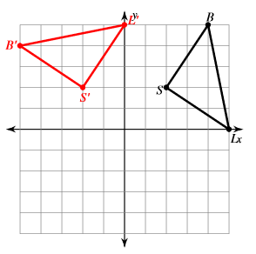  B B’  S S’  L L’ | 2.  J J’  K K’  L L’ | 3.  D D’  E E’  F F’  G G’

Do you notice a pattern? What happens to the coordinates of the Pre-Image when they are rotated about the origin?
Your Finding:

______________’s Finding: RULE: ________________________________________________________

______________’s Finding: RULE: ________________________________________________________

______________’s Finding: RULE: ________________________________________________________

Name: ____________________ Table #: _______ Period: _____ Date: ____
2.4A Rotations_Classwork (4)
OBJECTIVE: rotate the figures 90 degrees clockwise, 180 degrees, 270 degrees clockwise, 90 degrees counterclockwise about the origin. CCSS: 8.G.1, 2 and 3

Record the Pre-Image and Image coordinate pairs for each problem.

Rotate 180 degrees about the origin
1.  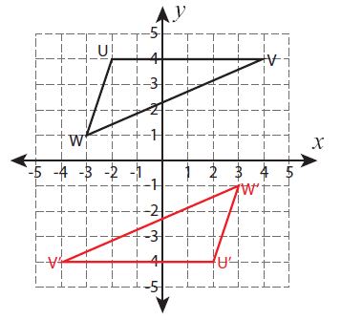  U U’  V V’  W W’ | 2.  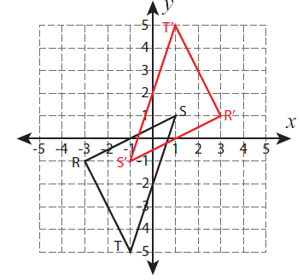  T T’  R R’  S S’ | 3.  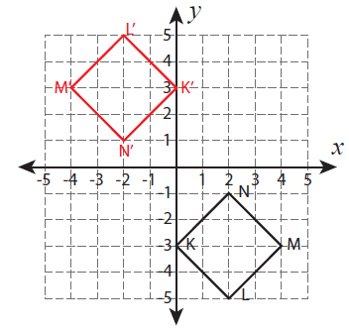  K K’  L L’  M M’  N N’

Do you notice a pattern? What happens to the coordinates of the Pre-Image when they are rotated about the origin?
Your Finding:

______________’s Finding: RULE: ________________________________________________________

______________’s Finding: RULE: ________________________________________________________

______________’s Finding: RULE: ________________________________________________________

Find the ordered pair after the designated rotation about the origin.

1.  Rotate A(3, -5) 90º clockwise about the origin  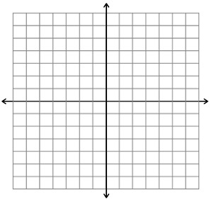 | 2.  Rotate A(3, -5) 180º about the origin. | 3.  Rotate A(3, -5) 90º counterclockwise about the origin.
4.  Rotate B(2, 4) 90º clockwise about the origin | 5.  Rotate B(2, 4) 180º about the origin. | 6.  Rotate B(2, 4) 90º counterclockwise about the origin.

WARM UP
1. A figure lies entirely in Quadrant IV. If you  reflect in the y-axis, in which quadrant is the  image?  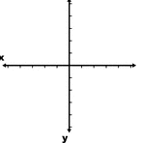 | 2. A figure lies entirely in Quadrant III. If you  reflect in the x-axis, in which quadrant is the  image?

HW: (2.4A) p. 65 #2 – 5, 7 – 12, 30 – 33 (solutions on p. A14)
