Name: _________________________ Table #: ________ Period: ______ Date: _______
2.4B Dividing Decimals_Classwork

Objective: Students will be able to multiply and divide decimals; apply real-life application CCSS.7.NS.1d
HW: worksheet 2.4B HW

WARM-UP
Solve
- $1.35--2.451=$ | - $56.23-35.1=$ | - $\left(2.1\right)\left(1.03\right)=$

DIVIDING RATIONAL NUMBERS—DECIMALS

- Move the decimal point in the divisor (the number outside the box) to the right to make it a whole number.
- Move the decimal point in the dividend (the number inside the box) to the right the same number of places.
- Divide as you would with whole numbers.
- Move the decimal point into the quotient (your answer) directly above the decimal point you moved in the dividend.
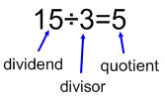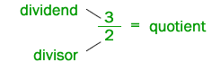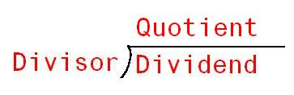
Practice Problems
- $5.76÷1.6$ | - $\frac{8}{0.5}$ | - $71.5÷25$

Word Problems for Dividing Decimals

- What is the quotient of 34.6 divided by 2? | - The Henry family drove 276.5 miles on the family vacation. They used 10 gallons of gas. How many miles per gallon of gas did they get to the trip?
- Jason spend $10.00 for school lunches. If each lunch is $2.50, how many lunches did he buy? | - Mrs Cao bought 1.5 pounds of ground beef from Kroger. The total of the purchase was $6.75. What was the price per pound?

