Name: ______________________ Table #: _________ Period: ______________ Date: ________
2.4C Multiplying Fractions_Classwork
Review
- (-12)(-5) = | - (1.3)(-0.1) = | - (-14)(4.4) =

Example 1  $$Find \frac{1}{3} of \frac{2}{5} (one-third of two-fifths)$$  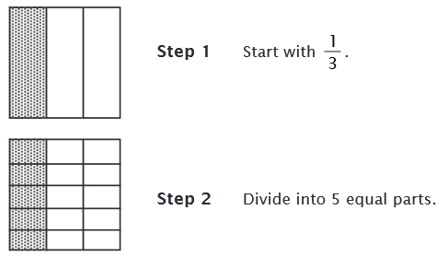  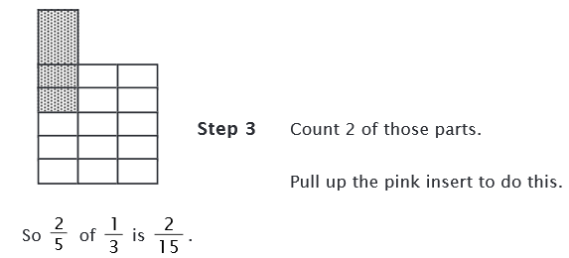 | Example 2  $$Find \frac{2}{3} of \frac{5}{6} (two-thirds of five-sixths)$$

$$\frac{Numerator times numerator (shaded rectangle)}{denominator times denominator (total \# of parts)}$$
- Change mixed fractions into improper fractions. Change whole number into a fraction by putting a 1 in the denominator
- Determine if the answer is positive or negative
$$-∙-=+ + ∙+=+ - ∙+=- + ∙-=-$$
- Simplify both fractions before multiplying if possible
- Multiply both numerators
- Multiply both denominators
- Simplify the answer

- $\frac{3}{7}∙-7=$ | - $-1\frac{3}{4}∙6=$ | - $-2∙-1\frac{5}{7}=$
- ${(-\frac{3}{4})}^{2}=$ | - ${-(\frac{3}{4})}^{2}=$ | - ${(\frac{3}{4})}^{3}$=

Multiplying Fractions Word Problems
- Bill wants to put a large mural on a wall that is $9\frac{1}{3}$ feet long and $8\frac{1}{8}$ feet wide. Find the area of the wall. If the mural is 100 square feet, will it fit on the wall? | - $\frac{1}{5}$ of today’s college students began using computers between the age of 5 and 8. If a college has 3,500 students, how many of the students began using computers between the ages of 5 and 8?
- A paper published in a medical journal reported that about $\frac{11}{25}$ of girls ages 16 to 17 do not exercise at all. The entire study consisted of about 2,500 girls. About how many did not exercise? | - Catherine walks her dog $\frac{3}{4}$ mile every day. How far does she walk each week?

Name: ______________________ Table #: _________ Period: ______________ Date: ________
2.4C Multiplying Fractions_ Homework
