Name: __________________ Table #: ______ Period: ______ Date: _______
2.5A Notes – Similar Figures
Objective: Analyze two figures to determine if they are similar. Find unknown measures of similar figures. CCSS: 8.G.4
HW: (2.5A) p. 74 #4, 5, 8 – 13.
*** Start with warm up on back ***
Read p. 72-73. Fill in the blanks and use the examples to answer the questions below.
Triangle ABC is similar to Triangle DEF $\left(⊿ABC \sim ⊿DEF\right)$

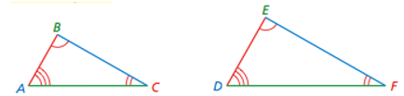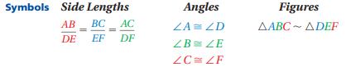

Two figures are similar when

- _____________________ side lengths are ____________________ and

- _____________________ angles are ___________________ .

2.5A EXAMPLE 1 (p. 72)
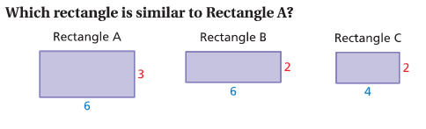

Big Ideas Math Video 2.5 – Example 1
Which parallelogram is similar to Parallelogram A?
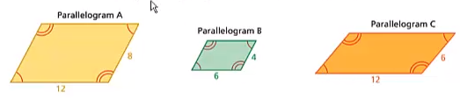

2.5A EXAMPLE2 (p. 73)
The triangles are similar. Find x.
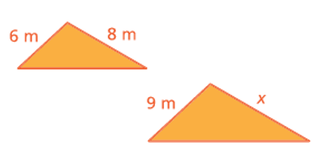
Big Ideas Math Video 2.5 – Example 2
The triangles are similar. Find x.
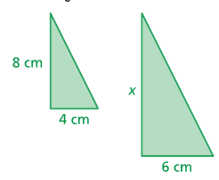
Tell whether the two figures are similar. Explain your reasoning.
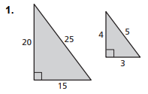 | 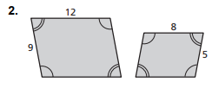

*******WARM UP – Use your notes to help answer the warm up questions********
- The vertices of a triangle are A(2, 5), B(1, 2) and C(3, 1). Reflect the triangle in the x-axis, and then rotate the triangle 90º counterclockwise about the origin. What are the coordinates of the image?
(2.3A Notes (back) and 2.4A or B Notes)

- The vertices of a triangle are A(2, 4), B(2, 1) and C(5, 1). Dilate the triangle with respect to the origin using a scale factor of 2. Then translate the triangle 2 units left and 1 unit up. What are the coordinates of the image?
(2.7 Notes and 2.2A or B Notes)

+++++++++++++++++++++++++++++++++++++++++++++++++++++++++++++++++++++++++++++++++++++
Lesson Launch
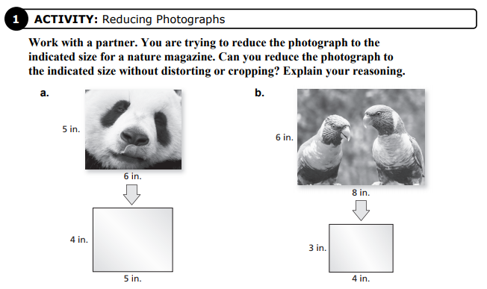
Warm up #1 & 2) Ch. Test, p. 96 #7 and #8

