Name: _________________ Table #: ______ Period: ______ Date: _______
2.5A Similar Figures_Classwork
Objective: name corresponding angles, and corresponding sides of similar figures; identify similar figures; find unknown measures of similar figures. CC.SS.8.G.4
HW: textbook pg 74 #4,5, #8-13 ALL
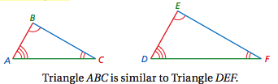

Two figures are similar when

- ____________________________________ side lengths are __________________________________ and
- ___________________________ angles are ___________________________________________ .

What is a proportion?

Are the two ratios 2:3 and 4:6 equal? Explain. Are the ratios 2:3 and 8:9 equal? Explain.

Reducing Photographs: You are trying to reduce the photograph to the indicated size for a natural magazine. Can you reduce the photograph to the indicated size without distorting or cropping? Explain your reasoning.
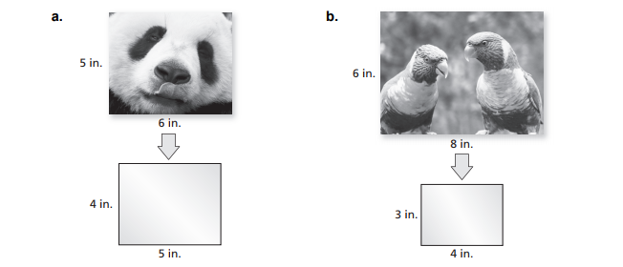
READ EXAMPLE #1, #2 (p. 72-73)
Copy the Big Ideas Math Videos (2.5, Example 1) and (2.5, Example 2)
2.5 – Example 1
Which parallelogram is similar to Parallelogram A?
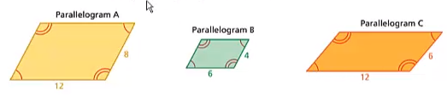

2.5 – Example 2
The triangles are similar. Find x.
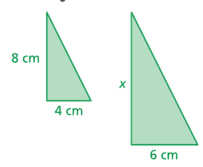

Tell whether the two figures are similar. Explain your reasoning.
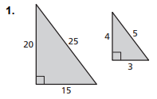 | 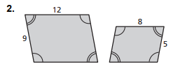

WARM-UP
- The triangles are similar. Find x.
- Which rectangle is similar to Rectangle A?
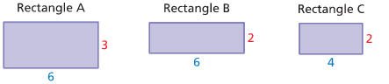

Name_______________________________________________ Table# _______________________ Per:_____________
2.5A Similar Figures – Exit Slip
1. Are the figures Similar? Use a proportion to prove your answer.
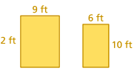

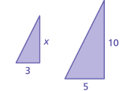
2. The figures are similar. Find the missing side length x.

Name_______________________________________________ Table# _______________________ Per:_____________
2.5 Similar Figures – Exit Slip
1. Are the figures Similar? Use a proportion to prove your answer.

2. The figures are similar. Find the missing side length x.

CLASS SET. DO NOT WRITE ON THIS. LEAVE FOR NEXT CLASS
HW: (2.5A) p. 74 #4, 5, 8 – 13 (solutions on p. A14)

