Name: __________________ Table #: ______ Period: ______ Date: _______
2.5B NOTES – Similar Figures
Objective: name corresponding angles, and corresponding sides of similar figures; identify similar figures; find unknown measures of similar figures. CC.SS.8.G.4 HW: 2.5B worksheet

EXAMLE 1: Are the figures Similar? Use proportional strategy to prove your answer.

EXAMPLE 2: An artist draws a replica of a painting this is on the Berlin Wall. The painting includes a red trapezoid. The shorter base of the similar trapezoid in the replica is 3.75 inches. What is the height h of the trapezoid in the replica?
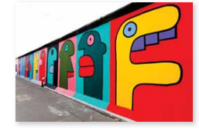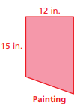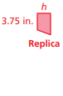
EXAMPLE 3: The artist draws a larger replica of the paining in Example 3. The shorter base of the similar trapezoid is 10 inches. What is the height h of this trapezoid?
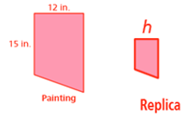
EXAMPLES. Round to the nearest hundredth if necessary.
- What is the height x of the flagpole?  Assume the triangles are similar.  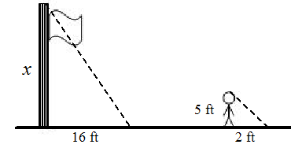 | - Similar Test Questions #18: A person standing 56 feet from a street light casts a shadow as shown. What is the height h of the street light? The street light is how many times taller than the person? Assume the triangles are similar.  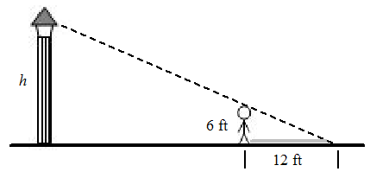
- What is the height x of the flagpole? Assume the triangles are similar.  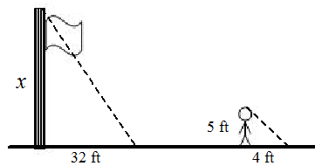 | - A person standing 21 feet from a street light casts a shadow as shown. The street light is how many times taller than the person? Assume the triangles are similar.  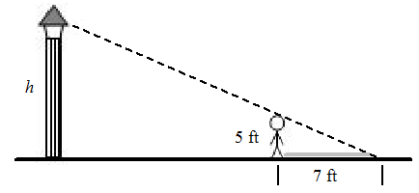
Similar Test Question to #15: Consider a figure in a coordinate plane. For each of the transformations below, first transform the figure as stated. Then reverse the order of the sentences and transform the original figure a second time. Did the sequences result in the same image or different image? HINT: Pick one point to test.
- Translate 2 units down, and then reflect in the y –axis.
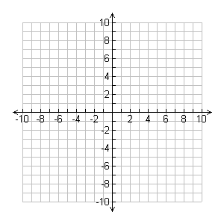
The sequences result in the __________________ image.

- Reflect over the y-axis, and then translate 3 right and 3 down.
The sequences result in the __________________ image.

Similar Test Question to #6: The red figure is congruent to the blue figure: Which would best describe a sequence of transformations in which the blue figure is the image of the red figure? (textbook pg 64. Ex. 5)

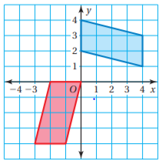
B
R

Name___________________________ Table# __________ Per:_____________ Date: _______
2.5B Similar Figures – Exit Slip

In a coordinate plane, draw the figures with the given vertices. Which figures are similar? Explain your reasoning.
- Rectangle A: (0,0), (4,0), (4,2), (0,2)  Rectangle B: (0,0), (-6,0), (-6,3), (0,3)  Rectangle C: (-8,8), (2,8), (2,4), (-8,4)  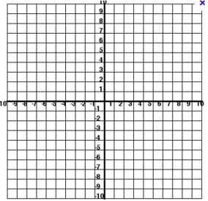 | EXPLAIN
- Figure A: (-4,2), (-2,2), (-2,0), (-4,0)  Figure B: (1,4), (4,4), (4,1), (1,1)  Figure C: (2,-1), (5,-1), (5,-3), (2,-3) | EXPLAIN

