Name: ______________________________________ Per ___ Table# ____ Date ______________
2.5B HOMEWORK – Similar Figures
- A flagpole casts a 20-foot shadow. At the same time, Shane, who is 6 feet tall, casts a 5-foot shadow. What is the height of the flagpole? Assume the triangles are similar.
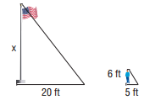

- Ruth is at the park standing next to a slide. Ruth is 5 feet tall, and her shadow is 4 feet long.
If the shadow of the slide is 4.8 feet long, what is the height of the slide? Assume the triangles
are similar.
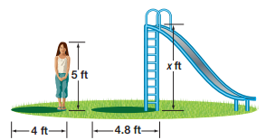

- The figures are similar. Find x.
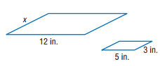
- The figures are similar. Find x.
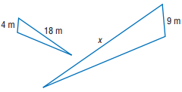
- A person standing 45 feet from a street light casts a shadow as shown. How many times taller is light to person? Assume the triangles are similar.
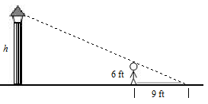

BACK
- Consider a figure in a coordinate plane. For each of the transformations below, first transform the figure as stated. Then reverse the order of the sentences and transform the original figure a second time. Did the sequences result in the same image or different image?

- Dilate the figure with respect to the origin using a scale factor of 3. Then rotate 90 degrees clockwise about the origin.
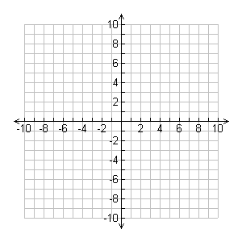
The sequences result in the __________________ image.

- Rotate 90 degrees clockwise about the origin. Then translate 4 units right and 2 units up.
The sequences result in the __________________ image.

Solutions: 1) 24 ft. 2) 6 ft. 3) 7.2 in. 4) 40.5m 5) 6 times

