Name: __________________ Table #: ______ Period: ______ Date: _______
2.5B Similar Figures_Classwork
Objective: name corresponding angles, and corresponding sides of similar figures; identify similar figures; find unknown measures of similar figures. CC.SS.8.G.4
EXAMPLE 3 (p. 73)
An artist draws a replica of a painting this is on the Berlin Wall. The painting includes a red trapezoid. The shorter base of the similar trapezoid in the replica is 3.75 inches. What is the height h of the trapezoid in the replica?
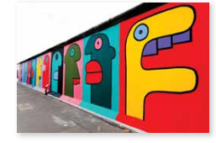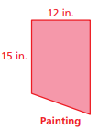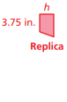
For You To Do
EXTRA EXAMPLE 3: The artist draws a larger replica of the paining in Example 3. The shorter base of the similar trapezoid is 10 inches. What is the height h of this trapezoid?
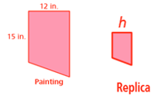
EXAMPLES
- What is the height x of the flagpole?  Assume the triangles are similar.  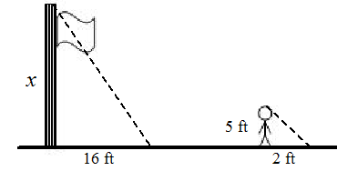 | - A person standing 56 feet from a street light casts a shadow as shown. What is the height h of the street light? Assume the triangles are similar.  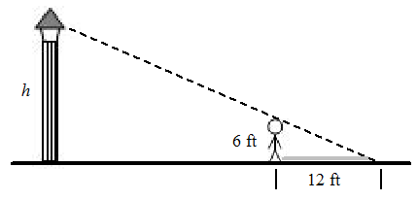
- What is the height x of the flagpole? Assume the triangles are similar.  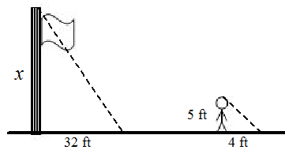 | - A person standing 21 feet from a street light casts a shadow as shown. What is the height h of the street light? Assume the triangles are similar.  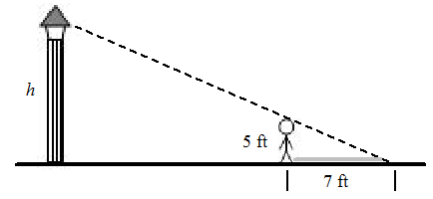
Name: ______________________________________ Per ___ Table# ____ Date ______________
2.5B Classwork – Similar Figures
- A flagpole casts a 20-foot shadow. At the same time, Shane, who is 6 feet tall, casts a 5-foot shadow. What is the height of the flagpole? Assume the triangles are similar.
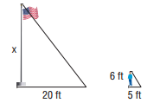

- Ruth is at the park standing next to a slide. Ruth is 5 feet tall, and her shadow is 4 feet long.
If the shadow of the slide is 4.8 feet long, what is the height of the slide? Assume the triangles
are similar.
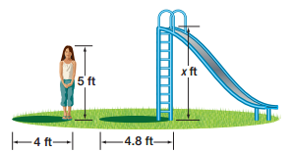

- The figures are similar. Find x.
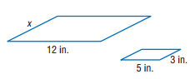
- The figures are similar. Find x.
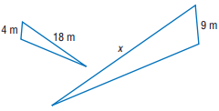
- A person standing 45 feet from a street light casts a shadow as shown. What is the height h of the street light? Assume the triangles are similar.
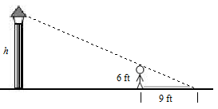

Solutions: 1) 24 ft. 2) 6 ft. 3) 7.2 in. 4) 40.5m 5) 36 ft.

