Name: ______________________ Table #: ______ Period: _____ Date: _____
2.6A HW
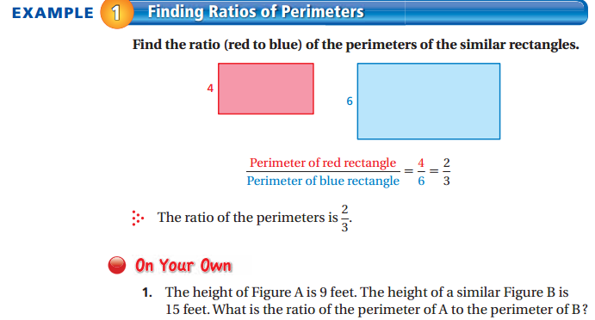

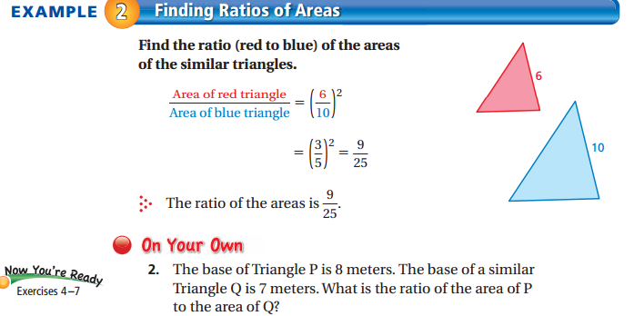

The two figures are similar. Find the ratios (shaded to nonshaded of the perimeters and of the areas).
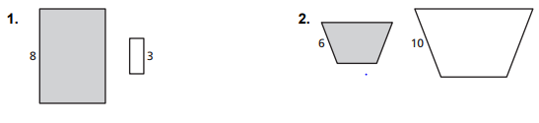

The polygons are similar. Find x.
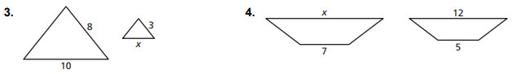

5. You buy two picture frames that are similar. The ratio of the corresponding side lengths is 4:5. What is the ratio of the areas?

6. Find the ratio (small to big rectangle) of the perimeters of the similar rectangles.
8
2

7. The height of Figure A is 8 feet. The height of a similar Figure B is 12 feet. What is the ratio of the perimeter of A to the perimeter of B?

8. Find the ratio (small triangle to big triangle) of the areas of the similar triangles.
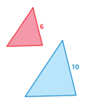

28
12
9. The base of Triangle P is 5 meters. The base of a similar Triangle Q is 10 meters. What is the ratio of the area of P to the area of Q?

